Perpendicularity

Definition
# Source: AI Source: Provided by: [Data Path: Persons Table -> ID Column: 1, Name_En Column: Motasem Essam] -> From: [ChatGPT] on [7/25/2026]
Perpendicularity is a geometric relationship in which two lines, line segments, rays, or other geometric objects intersect at a right angle of ${90}^{∘}$.
If two lines $l_{1}$ and $l_{2}$ are perpendicular, we write:
$$\boxed{l_{1}⊥l_{2}}$$
This is read as:
“Line $l_{1}$ is perpendicular to line $l_{2}$.”
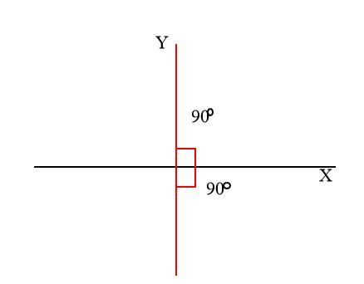
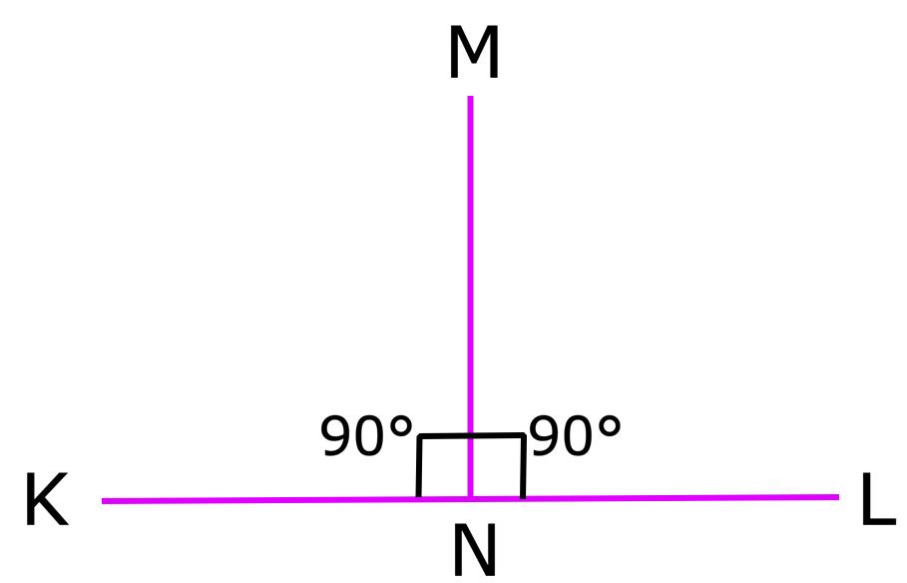
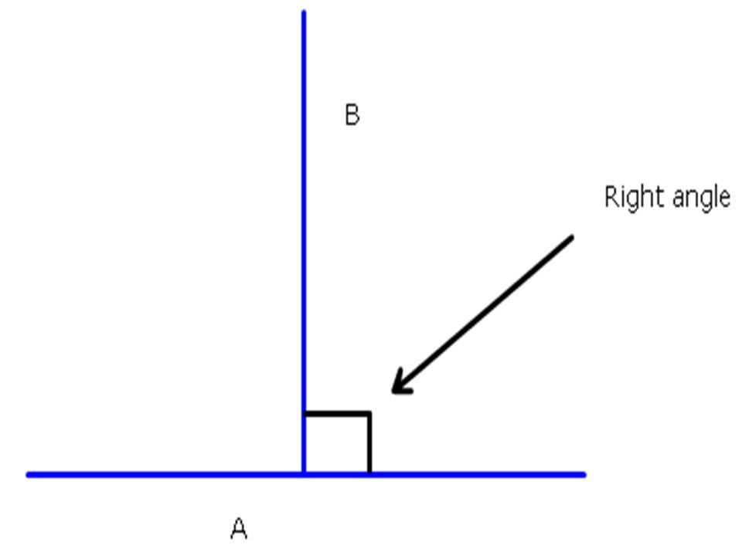
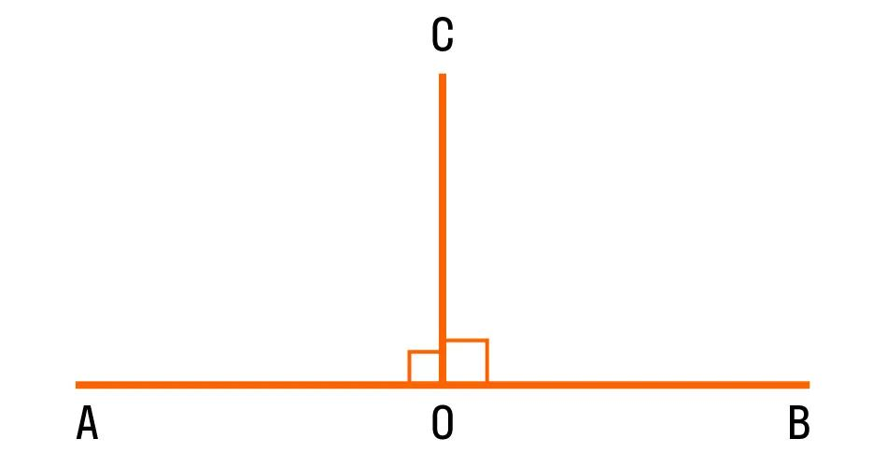
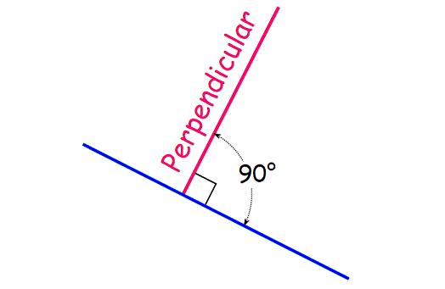

Purpose
# Source: AI Source: Provided by: [Data Path: Persons Table -> ID Column: 1, Name_En Column: Motasem Essam] -> From: [ChatGPT] on [7/25/2026]
Perpendicularity is used to:
- Identify lines that meet at ${90}^{∘}$.
- Define right angles.
- Construct accurate geometric figures.
- Analyze triangles and quadrilaterals.
- Determine distances between points and lines.
- Study coordinate geometry.
- Construct perpendicular bisectors.
- Support architecture, engineering, surveying, CAD, and construction.

Fundamental Idea
# Source: AI Source: Provided by: [Data Path: Persons Table -> ID Column: 1, Name_En Column: Motasem Essam] -> From: [ChatGPT] on [7/25/2026]
Two lines are perpendicular when they intersect to form a right angle.
A right angle measures:
$$\boxed{{90}^{∘}}$$
Therefore:
$$\boxed{l_{1}⊥l_{2}⟺∠\left(l_{1},l_{2}\right)={90}^{∘}}$$
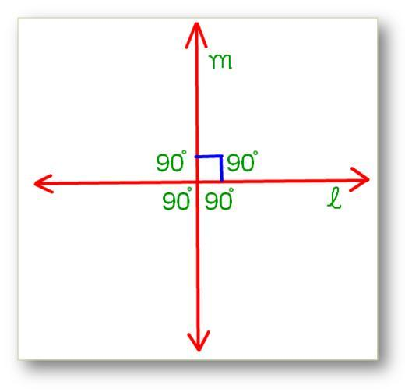
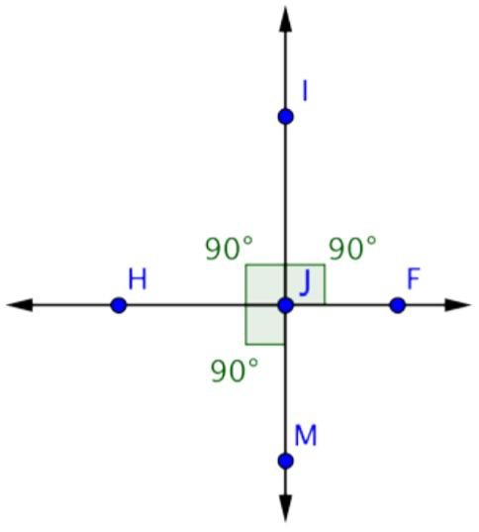
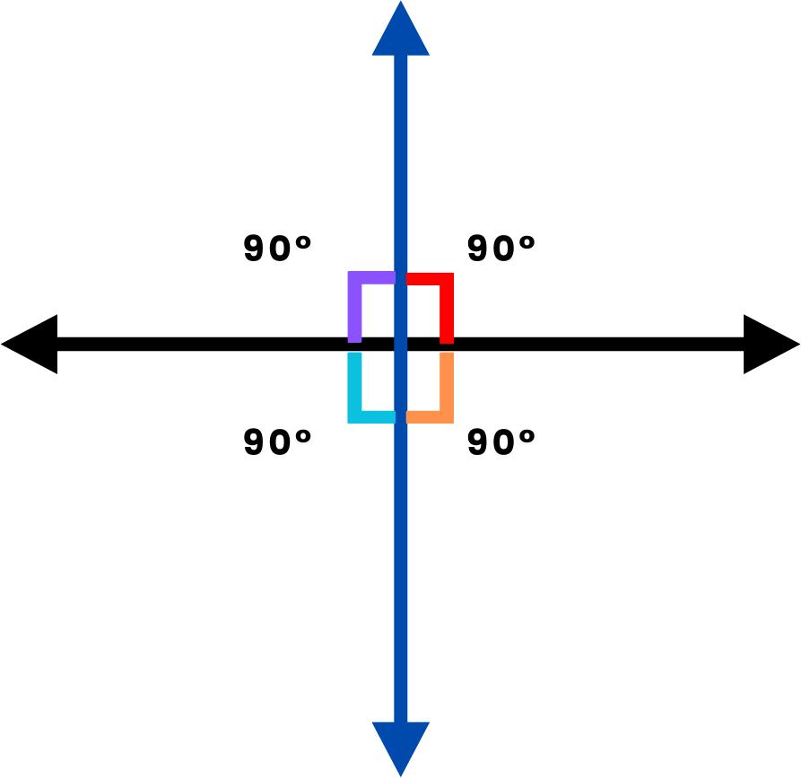
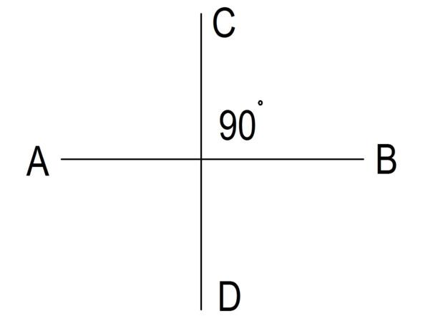
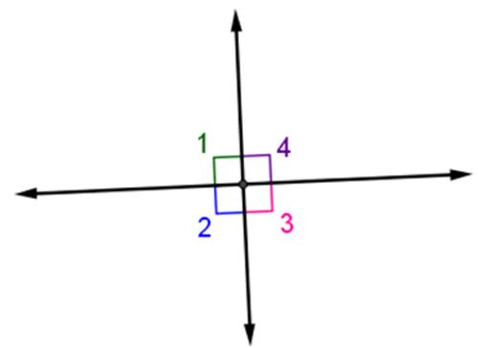

Notation
# Source: AI Source: Provided by: [Data Path: Persons Table -> ID Column: 1, Name_En Column: Motasem Essam] -> From: [ChatGPT] on [7/25/2026]
The symbol for perpendicularity is:
$$\boxed{⊥}$$
For example:
$$\boxed{AB⊥CD}$$
means that line $AB$ is perpendicular to line $CD$.

Right Angle
# Source: AI Source: Provided by: [Data Path: Persons Table -> ID Column: 1, Name_En Column: Motasem Essam] -> From: [ChatGPT] on [7/25/2026]
The fundamental angle associated with perpendicularity is the right angle.
$$\boxed{{90}^{∘}}$$
When two lines are perpendicular, they form four right angles at their intersection.
$$\boxed{{90}^{∘}+{90}^{∘}+{90}^{∘}+{90}^{∘}={360}^{∘}}$$
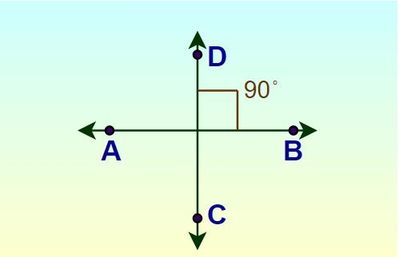

Characteristics of Perpendicular Lines
# Source: AI Source: Provided by: [Data Path: Persons Table -> ID Column: 1, Name_En Column: Motasem Essam] -> From: [ChatGPT] on [7/25/2026]
Perpendicular lines have the following properties:
- They intersect.
- Their intersection forms ${90}^{∘}$.
- They form four right angles.
- They are not parallel.
- They can be lines, line segments, or rays.
- The relationship is symmetric:
$$\boxed{l_{1}⊥l_{2}⇒l_{2}⊥l_{1}}$$

Perpendicular Line Segments
# Source: AI Source: Provided by: [Data Path: Persons Table -> ID Column: 1, Name_En Column: Motasem Essam] -> From: [ChatGPT] on [7/25/2026]
Two line segments can also be perpendicular.
For example:
$$\boxed{\overline{AB}⊥\overline{CD}}$$
if they intersect at a right angle.
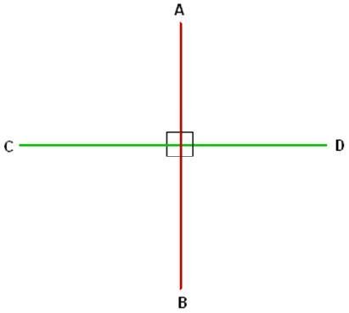
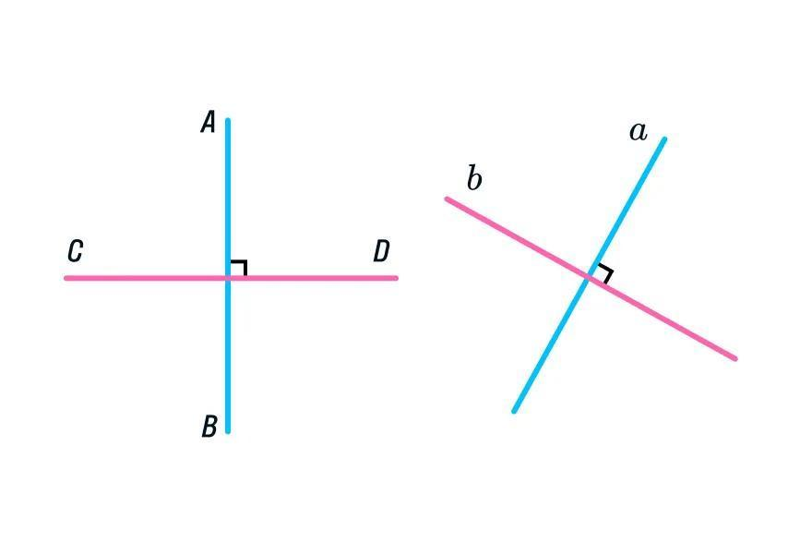
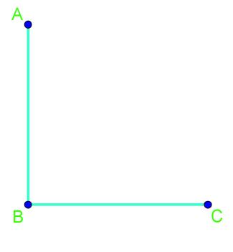

Perpendicular Rays
# Source: AI Source: Provided by: [Data Path: Persons Table -> ID Column: 1, Name_En Column: Motasem Essam] -> From: [ChatGPT] on [7/25/2026]
Two rays are perpendicular when their directions form a ${90}^{∘}$ angle.
For example:
$$\boxed{\overset{→}{AB}⊥\overset{→}{CD}}$$
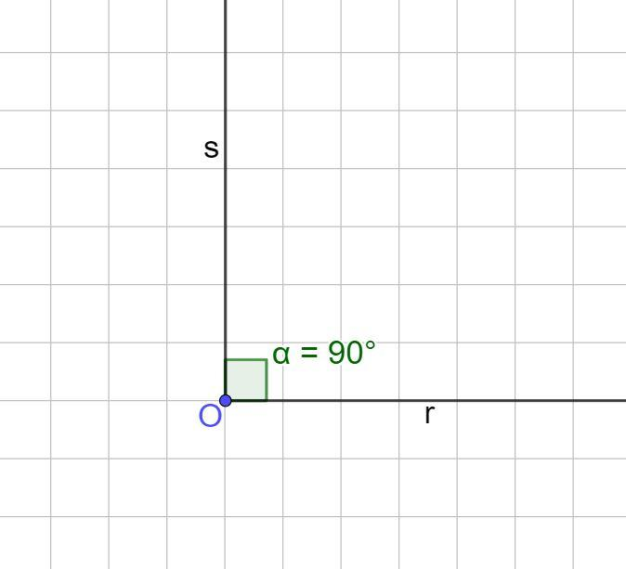
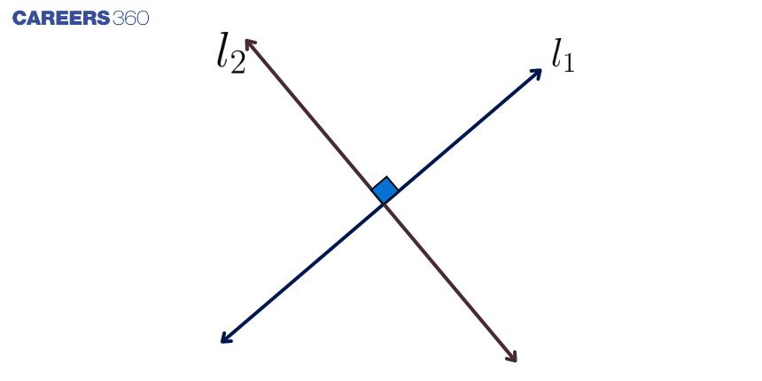
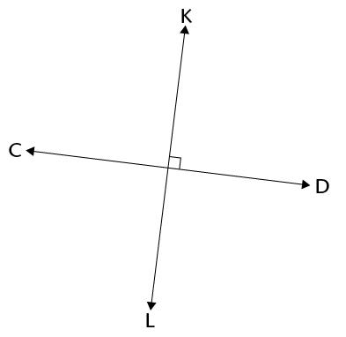

Perpendicularity and Parallelism
# Source: AI Source: Provided by: [Data Path: Persons Table -> ID Column: 1, Name_En Column: Motasem Essam] -> From: [ChatGPT] on [7/25/2026]
Perpendicularity and parallelism are different relationships.
Parallel Lines
$$\boxed{l_{1}∥l_{2}}$$
They do not intersect.
Perpendicular Lines
$$\boxed{l_{1}⊥l_{2}}$$
They intersect at:
$$\boxed{{90}^{∘}}$$
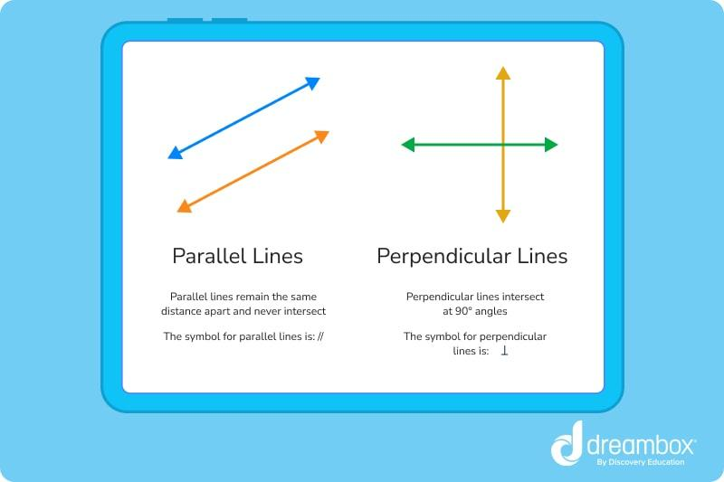
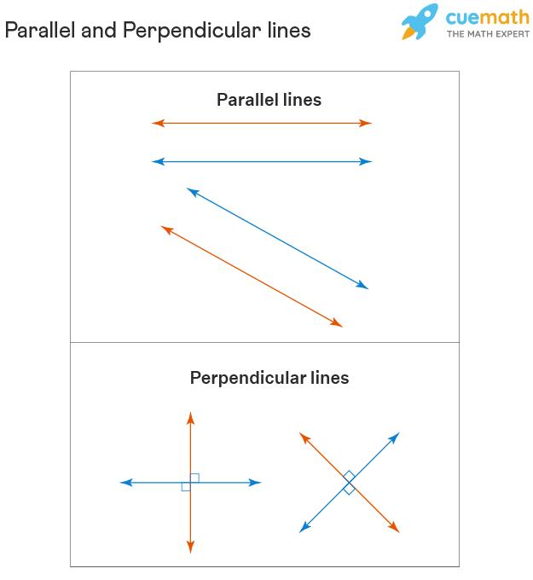
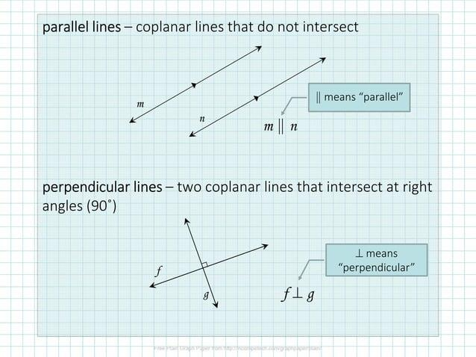
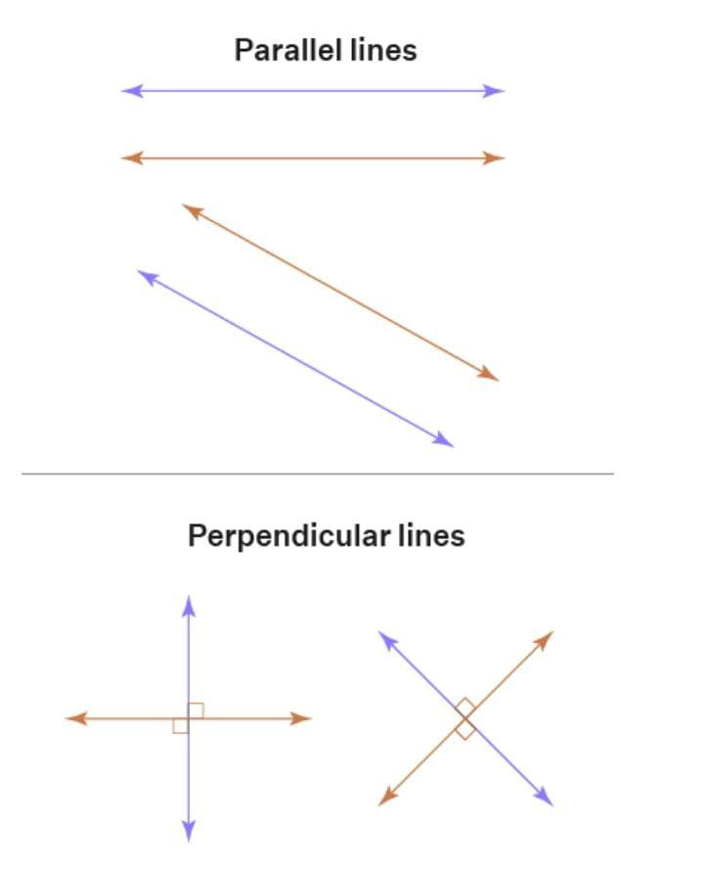

Perpendicularity in a Coordinate Plane
# Source: AI Source: Provided by: [Data Path: Persons Table -> ID Column: 1, Name_En Column: Motasem Essam] -> From: [ChatGPT] on [7/25/2026]
In coordinate geometry, perpendicular lines can be identified using their slopes.
For two non-vertical lines with slopes $m_{1}$ and $m_{2}$:
$$\boxed{m_{1}m_{2}=-1}$$
Therefore:
$$\boxed{m_{2}=-\frac{1}{m_{1}}}$$
This means that the slopes of two perpendicular non-vertical lines are negative reciprocals.
Example
Suppose:
$$m_{1}=2$$
Then the perpendicular slope is:
$$m_{2}=-\frac{1}{2}$$
because:
$$2\left(-\frac{1}{2}\right)=-1$$
Therefore:
$$\boxed{m_{1}m_{2}=-1}$$
and the lines are perpendicular.
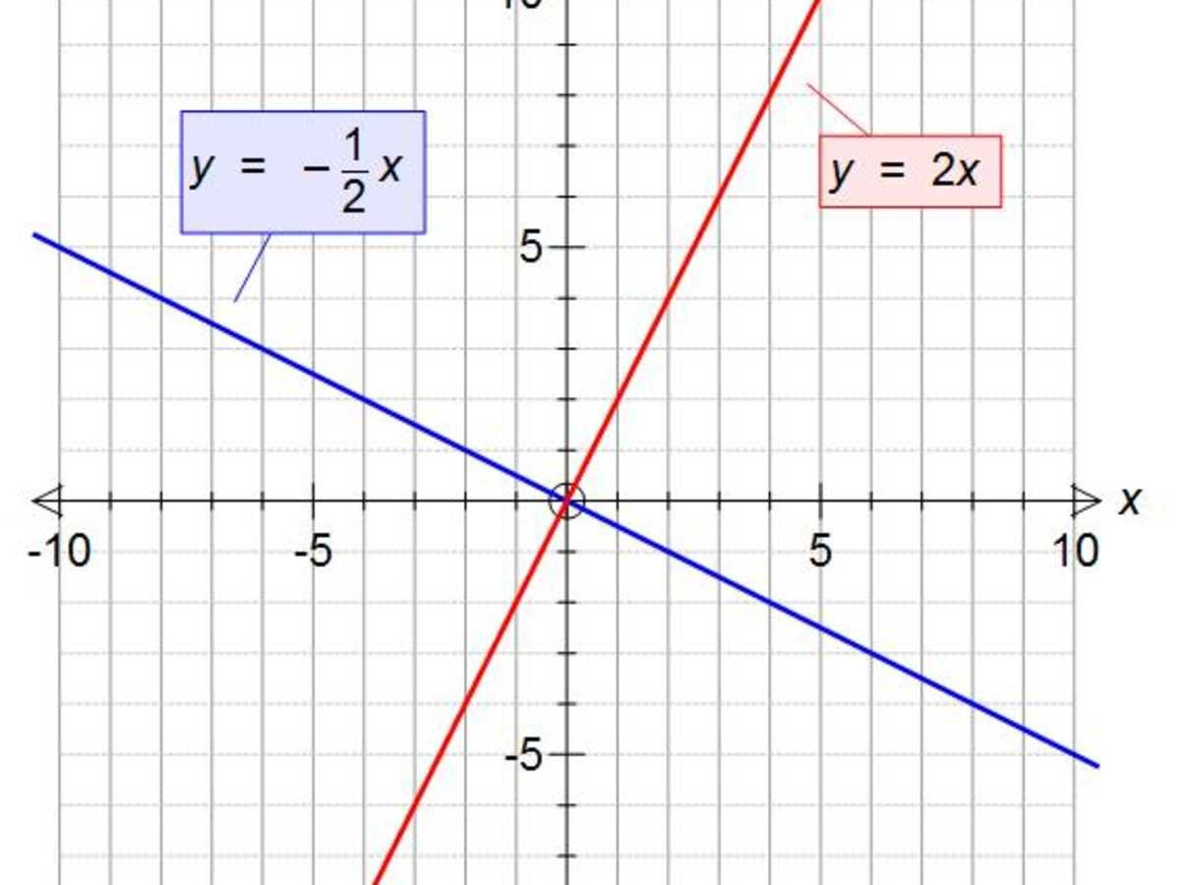
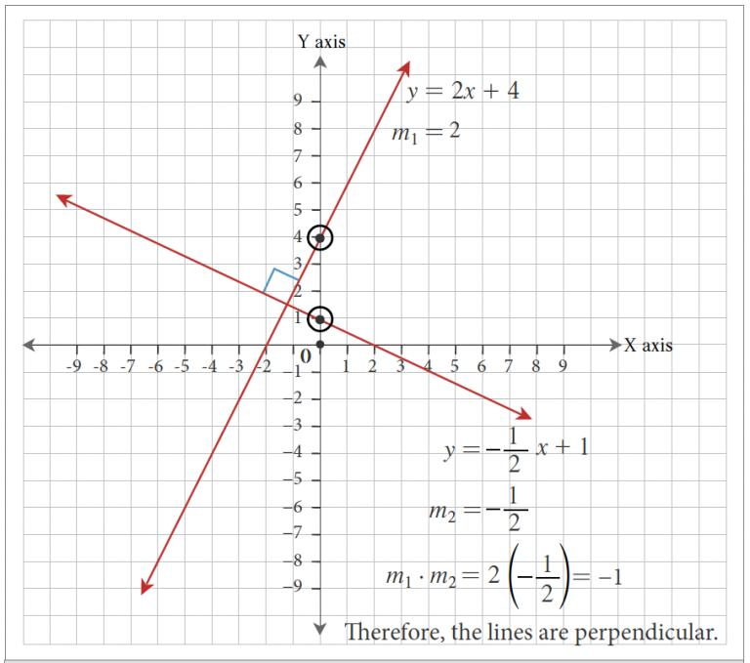
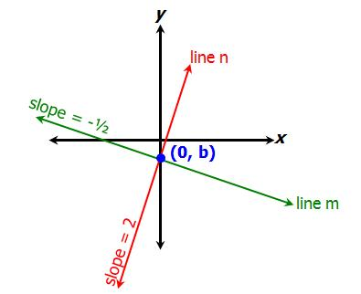
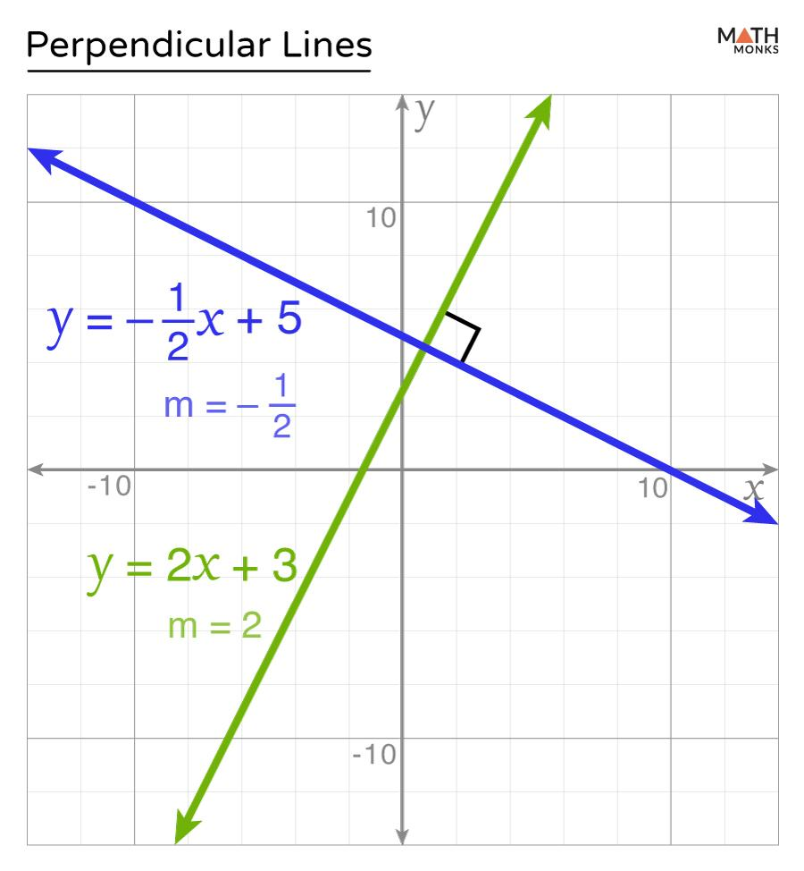
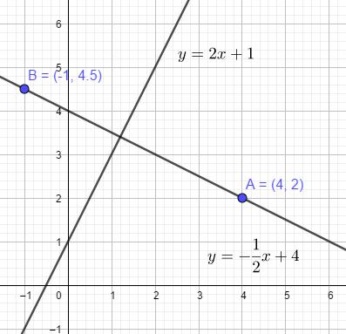

Horizontal and Vertical Lines
# Source: AI Source: Provided by: [Data Path: Persons Table -> ID Column: 1, Name_En Column: Motasem Essam] -> From: [ChatGPT] on [7/25/2026]
A horizontal line and a vertical line are perpendicular.
For example:
$$y=3$$
is horizontal, while:
$$x=5$$
is vertical.
Therefore:
$$\boxed{y=3⊥x=5}$$
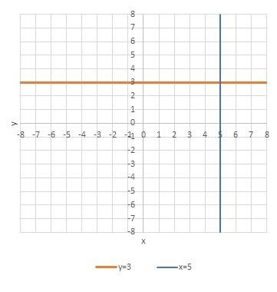
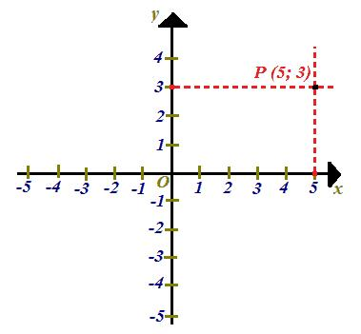
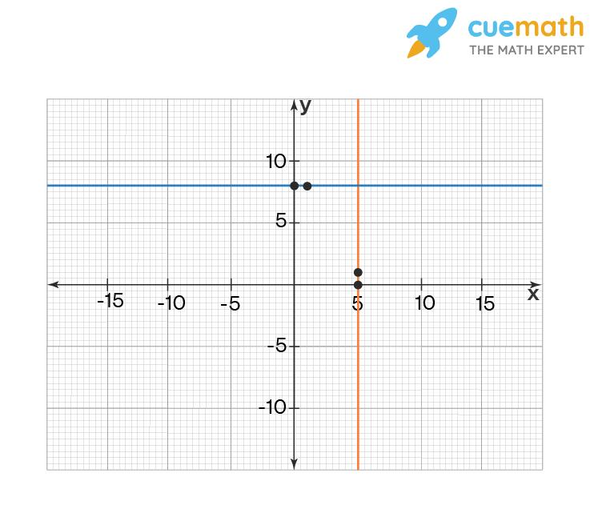

Perpendicular Bisector
# Source: AI Source: Provided by: [Data Path: Persons Table -> ID Column: 1, Name_En Column: Motasem Essam] -> From: [ChatGPT] on [7/25/2026]
A perpendicular bisector is a line that:
- Intersects a line segment at (90^\circ).
- Passes through the segment's midpoint.
If $M$ is the midpoint of $\overline{AB}$, and line $l$ passes through $M$ at ${90}^{∘}$, then:
$$\boxed{AM=MB}$$
and:
$$\boxed{l⊥AB}$$
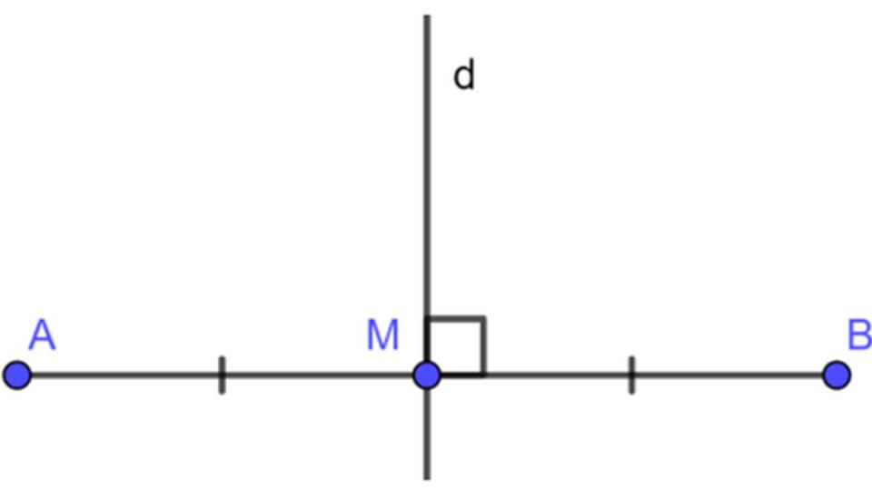
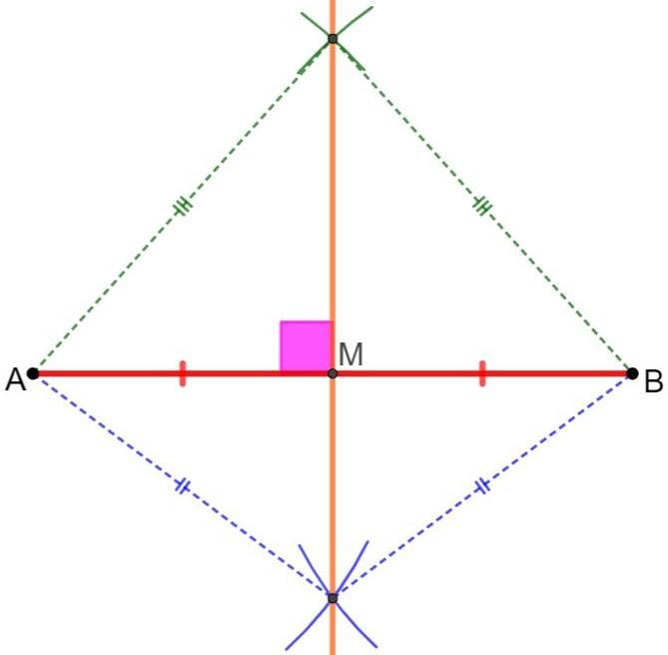
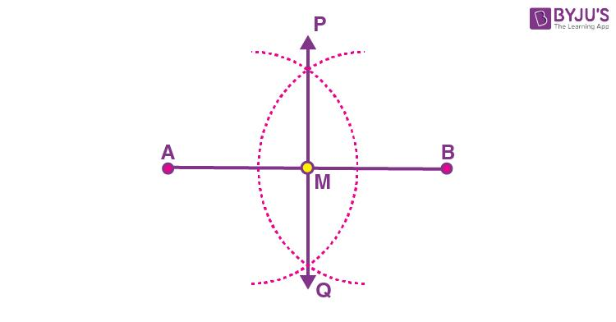
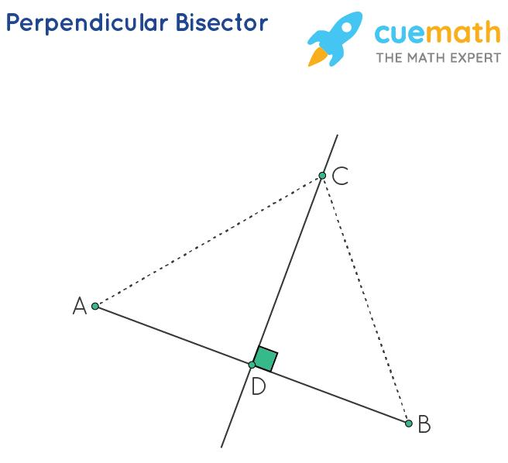
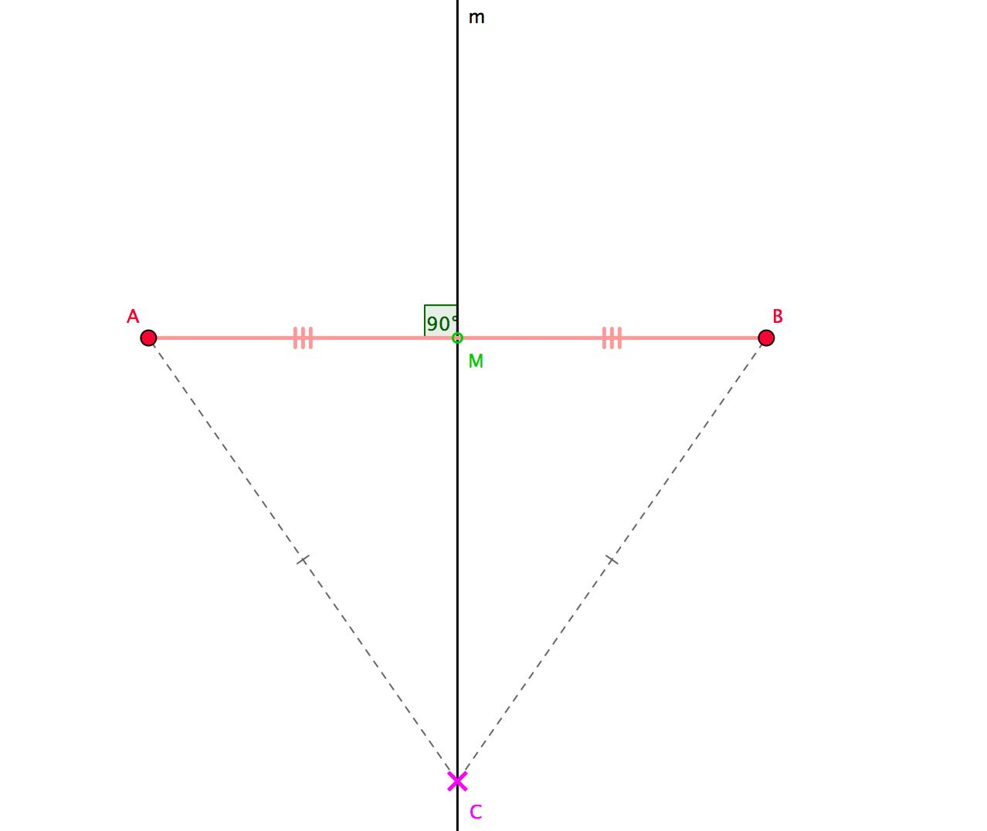

Important Property of a Perpendicular Bisector
# Source: AI Source: Provided by: [Data Path: Persons Table -> ID Column: 1, Name_En Column: Motasem Essam] -> From: [ChatGPT] on [7/25/2026]
Every point on the perpendicular bisector of a segment is equidistant from the two endpoints.
If $P$ lies on the perpendicular bisector of $\overline{AB}$, then:
$$\boxed{PA=PB}$$
This property is fundamental in geometric constructions.

Perpendicularity in Triangles
# Source: AI Source: Provided by: [Data Path: Persons Table -> ID Column: 1, Name_En Column: Motasem Essam] -> From: [ChatGPT] on [7/25/2026]
Perpendicularity is particularly important in triangles.
Right Triangle
A right triangle contains one right angle:
$$\boxed{{90}^{∘}}$$
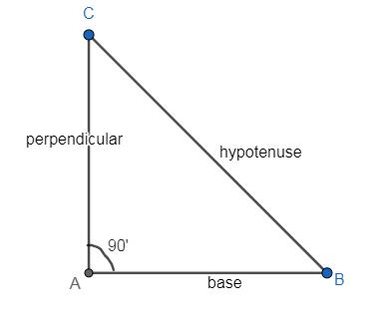
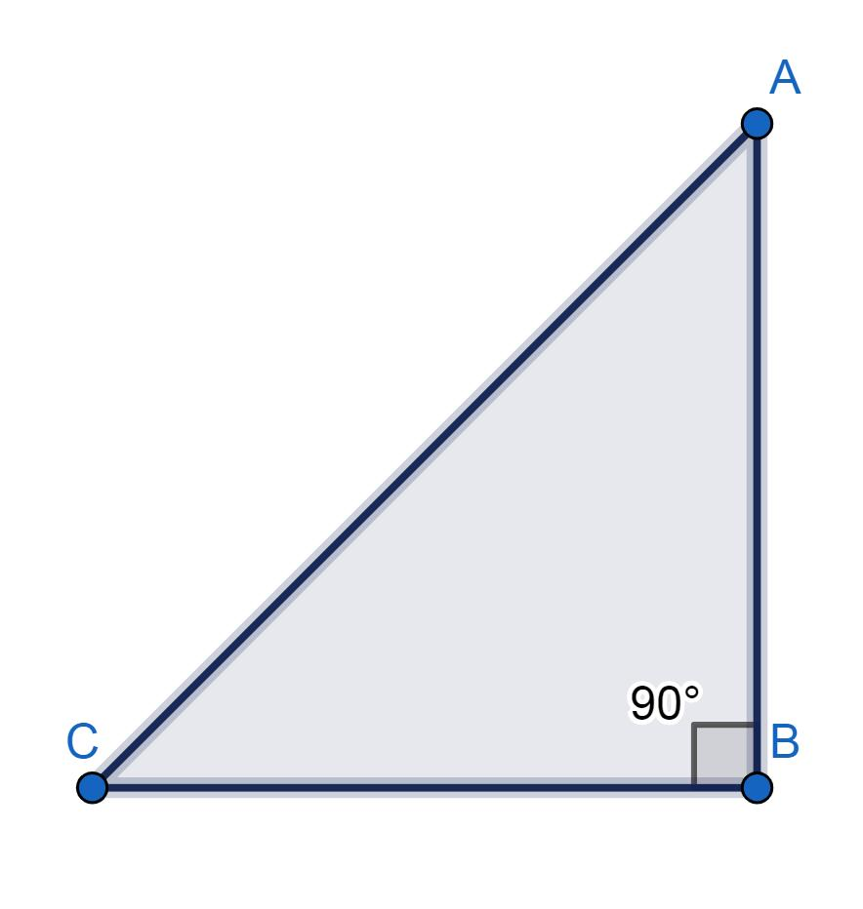
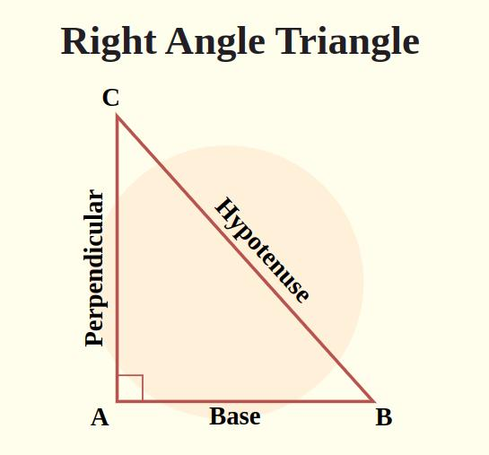
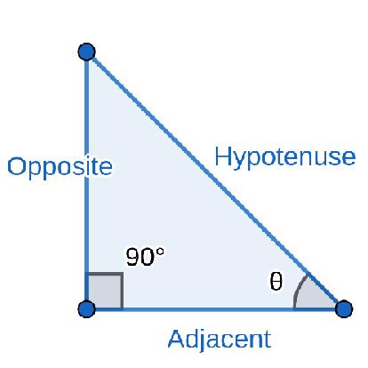
The two sides forming the right angle are perpendicular:
$$\boxed{AB⊥AC}$$

Altitude of a Triangle
# Source: AI Source: Provided by: [Data Path: Persons Table -> ID Column: 1, Name_En Column: Motasem Essam] -> From: [ChatGPT] on [7/25/2026]
An altitude is a line segment drawn from a vertex perpendicular to the opposite side or its extension.
For triangle $ABC$, if $AD$ is an altitude:
$$\boxed{AD⊥BC}$$
Therefore:
$$\boxed{∠ADB={90}^{∘}}$$
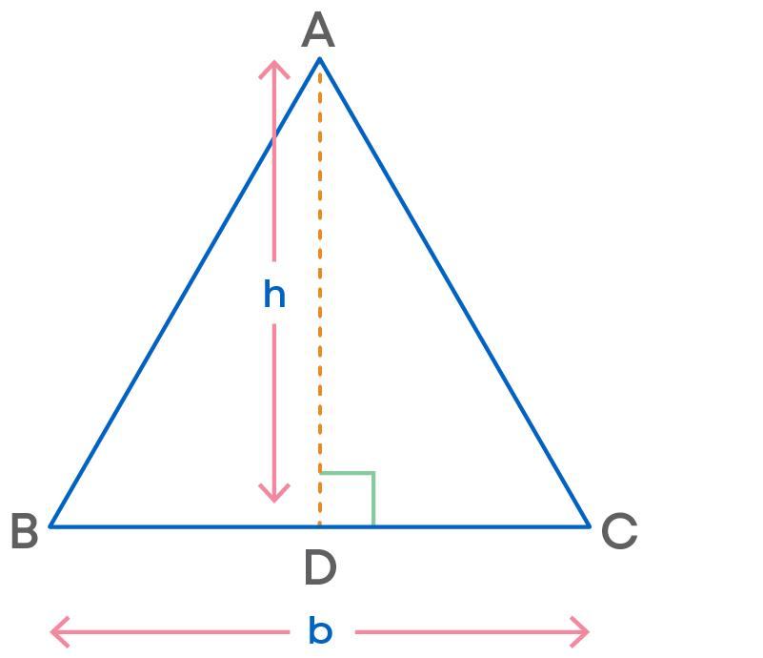
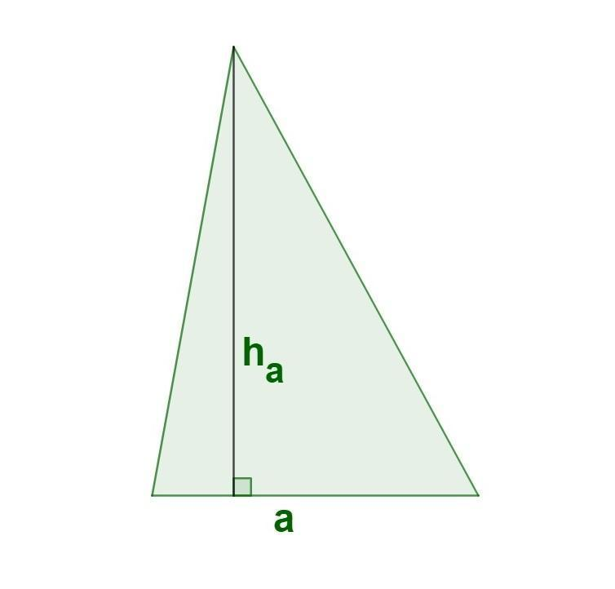
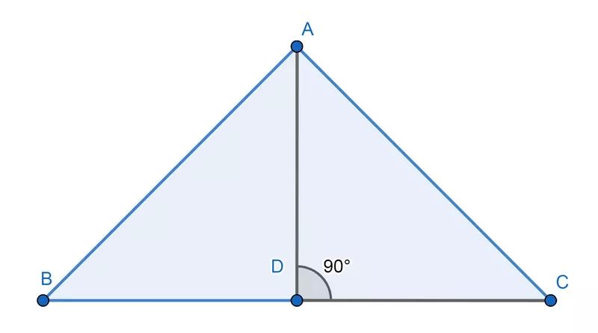
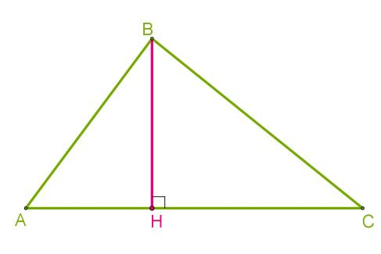

Perpendicularity and Distance
# Source: AI Source: Provided by: [Data Path: Persons Table -> ID Column: 1, Name_En Column: Motasem Essam] -> From: [ChatGPT] on [7/25/2026]
The shortest distance from a point to a line is measured along a perpendicular segment.
If $P$ is a point and $AB$ is a line, then the shortest distance from $P$ to $AB$ is:
$$\boxed{PD}$$
where:
$$\boxed{PD⊥AB}$$
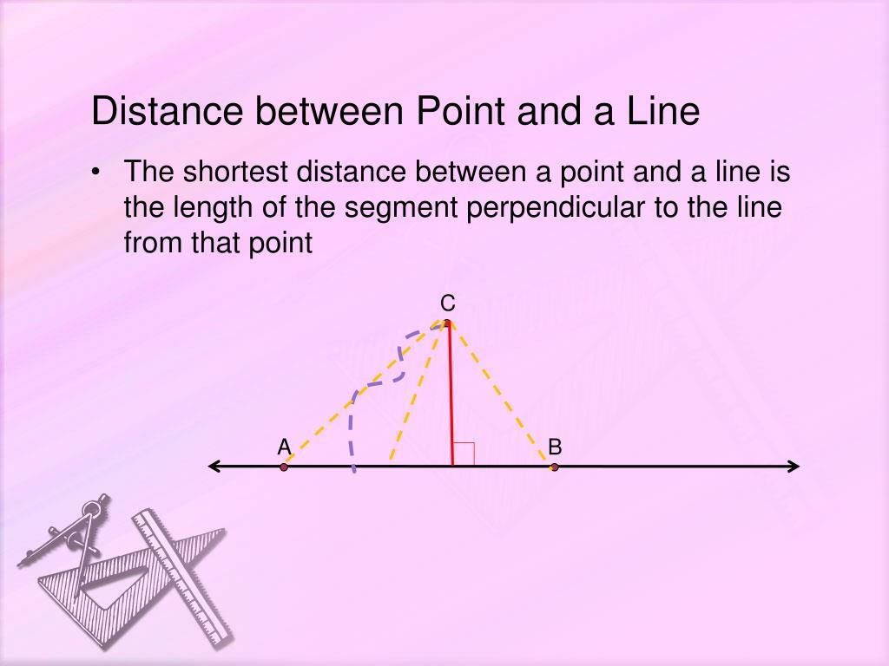
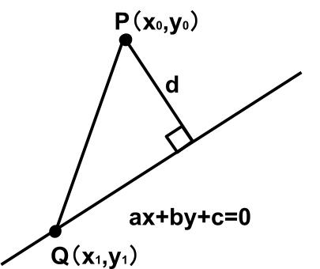
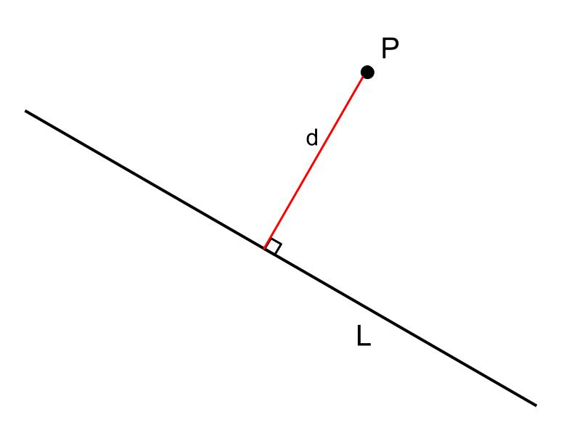
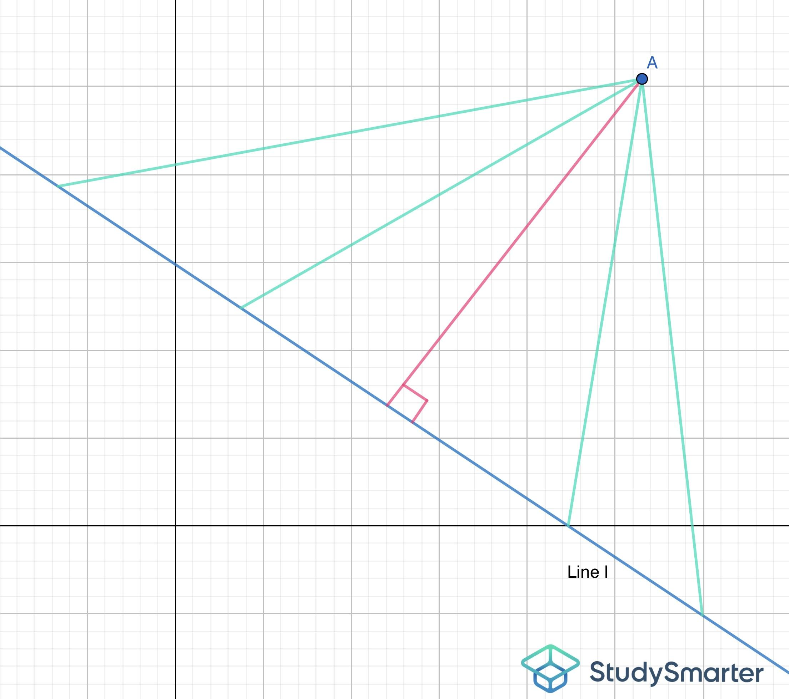

Perpendicularity in Polygons
# Source: AI Source: Provided by: [Data Path: Persons Table -> ID Column: 1, Name_En Column: Motasem Essam] -> From: [ChatGPT] on [7/25/2026]
Perpendicular sides occur in many common polygons.

Rectangle
# Source: AI Source: Provided by: [Data Path: Persons Table -> ID Column: 1, Name_En Column: Motasem Essam] -> From: [ChatGPT] on [7/25/2026]
Adjacent sides of a rectangle are perpendicular.
$$\boxed{AB⊥BC}$$
and:
$$\boxed{BC⊥CD}$$
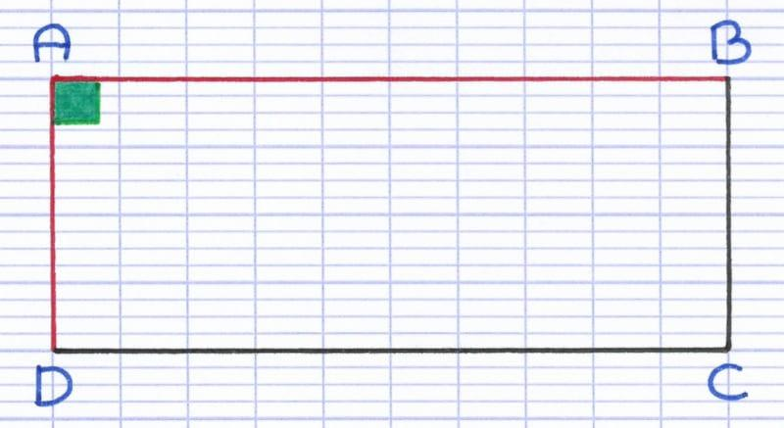
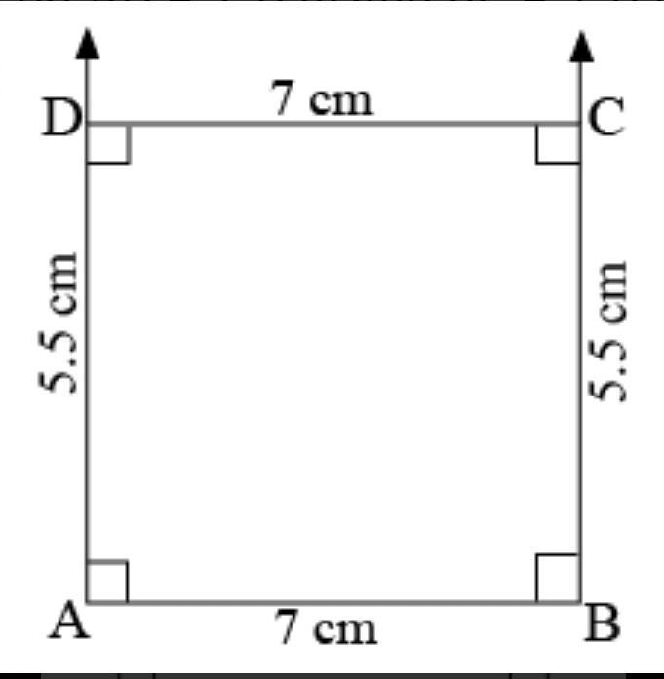
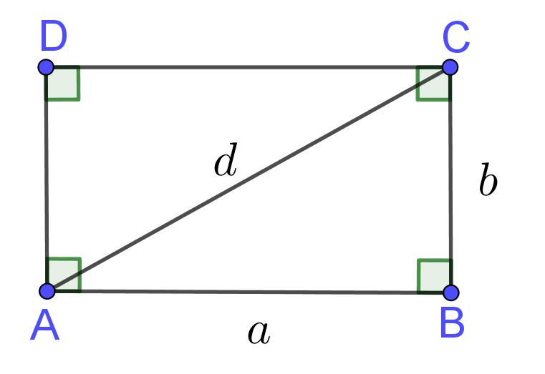
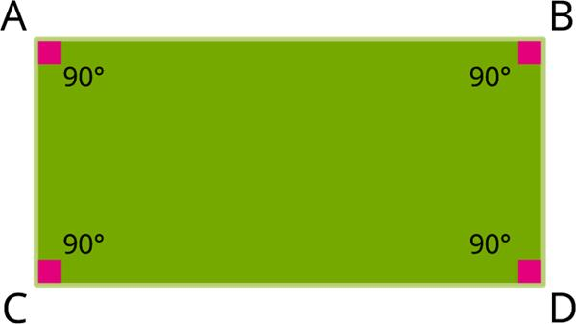
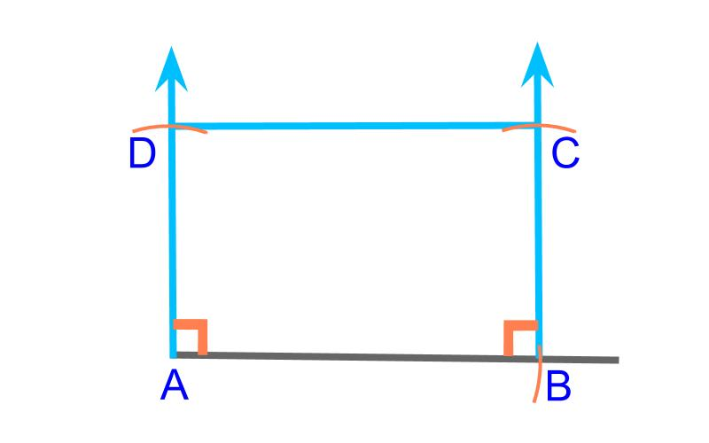

Square
# Source: AI Source: Provided by: [Data Path: Persons Table -> ID Column: 1, Name_En Column: Motasem Essam] -> From: [ChatGPT] on [7/25/2026]
Every pair of adjacent sides of a square is perpendicular.
$$\boxed{AB⊥BC}$$
A square therefore has four right angles.
$$\boxed{4×{90}^{∘}={360}^{∘}}$$
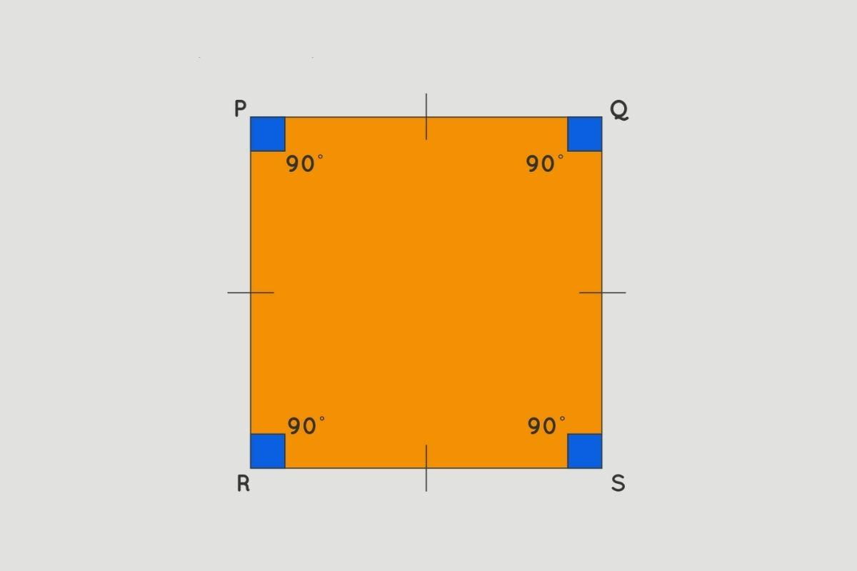
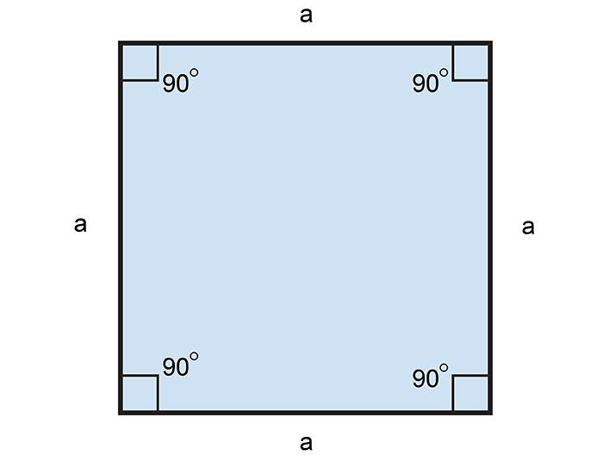
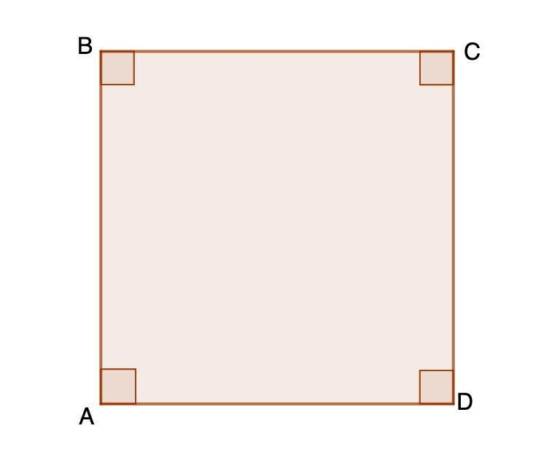
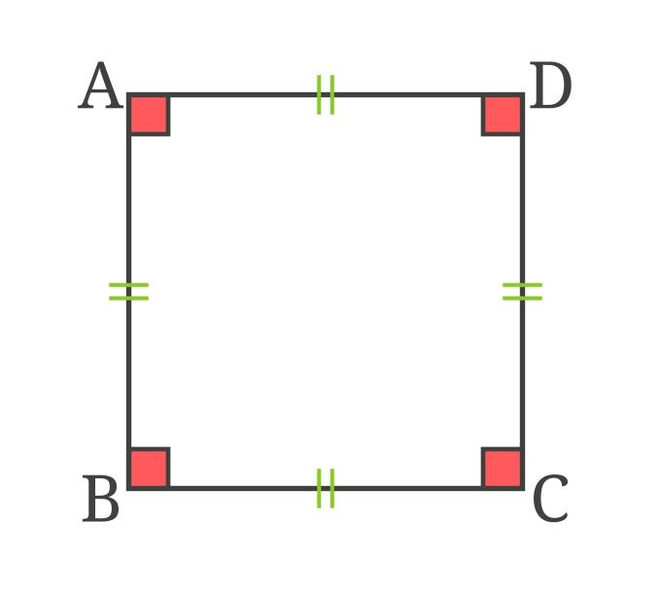
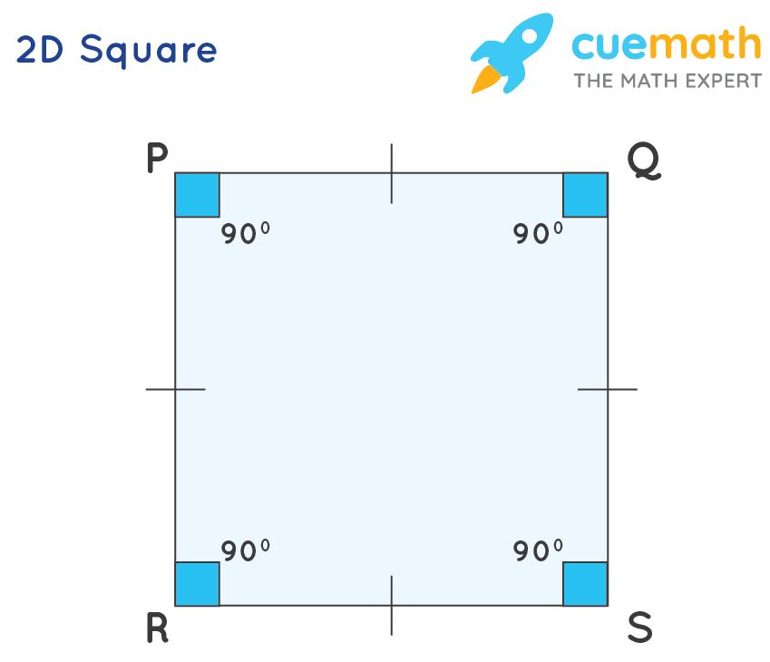

Perpendicular Diagonals
# Source: AI Source: Provided by: [Data Path: Persons Table -> ID Column: 1, Name_En Column: Motasem Essam] -> From: [ChatGPT] on [7/25/2026]
Some geometric figures have perpendicular diagonals.
For example, the diagonals of a rhombus are perpendicular:
$$\boxed{AC⊥BD}$$
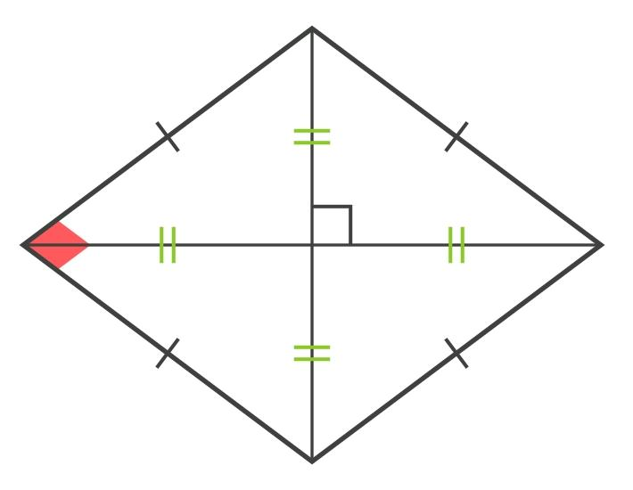
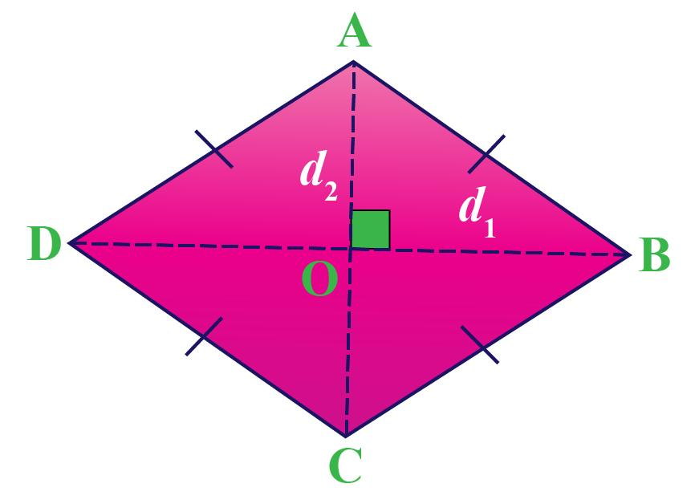
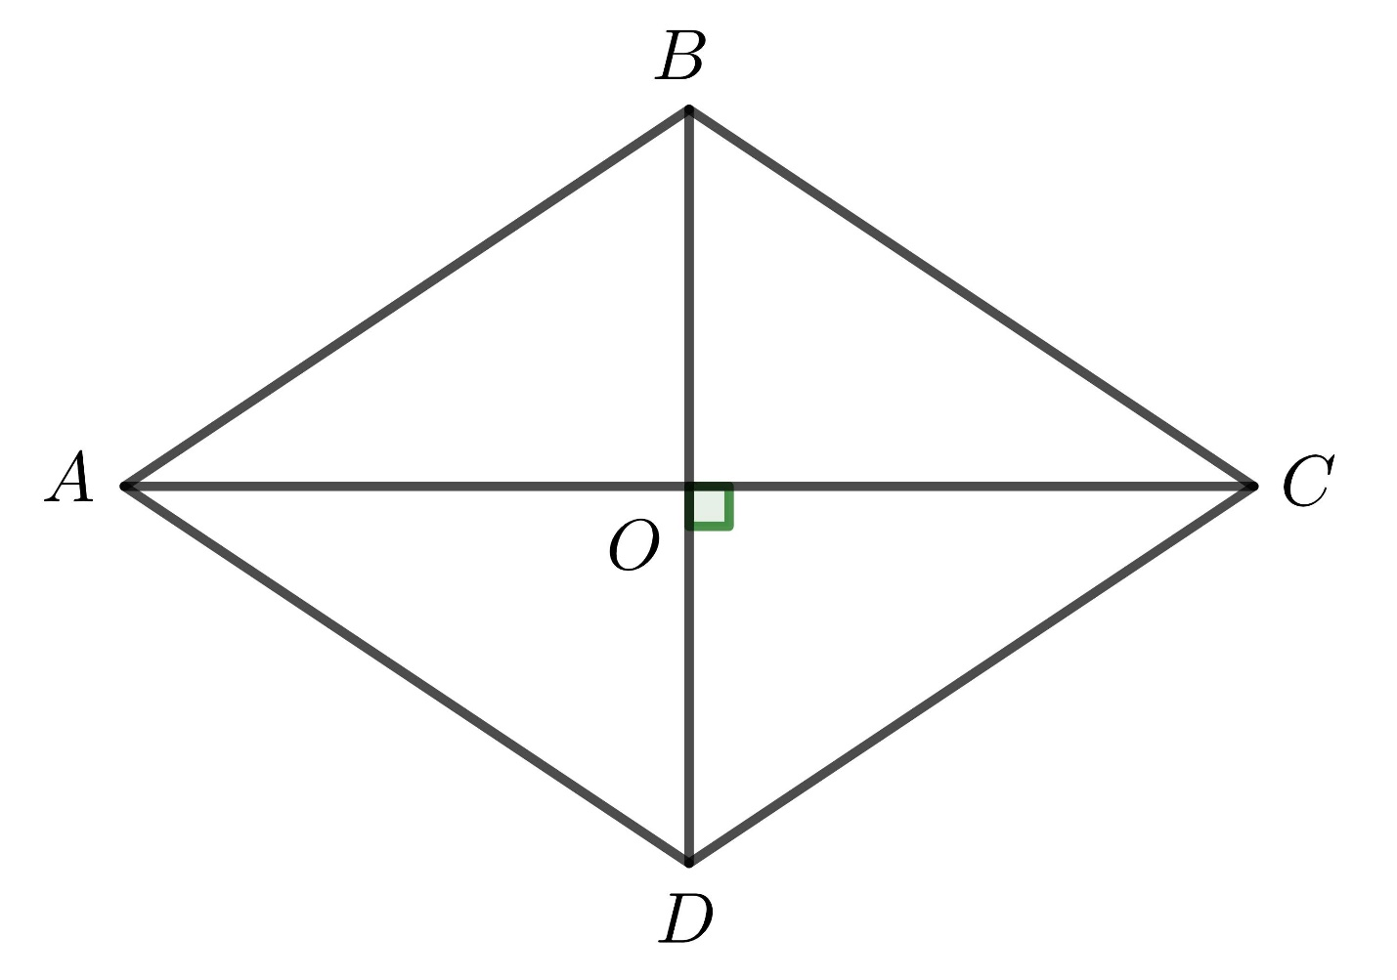
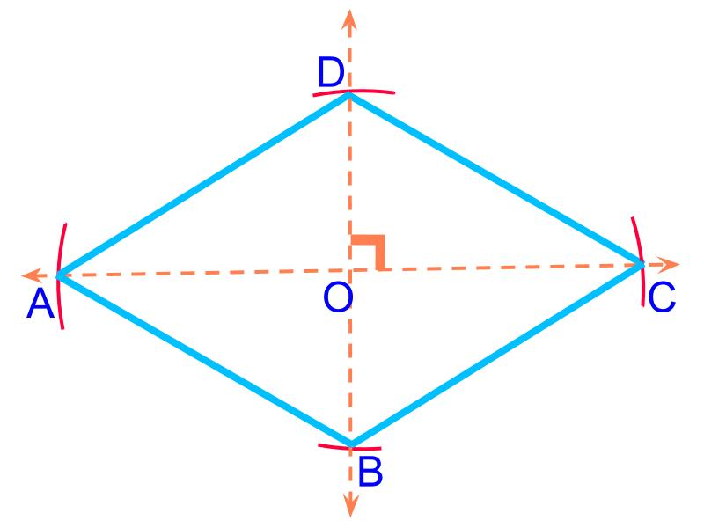
A square also has perpendicular diagonals.
However, not every quadrilateral has perpendicular diagonals.

Perpendicularity and Angles
# Source: AI Source: Provided by: [Data Path: Persons Table -> ID Column: 1, Name_En Column: Motasem Essam] -> From: [ChatGPT] on [7/25/2026]
If two lines are perpendicular, the four angles formed at their intersection are:
$$\boxed{{90}^{∘}}$$
Thus:
$$∠1=∠2=∠3=∠4={90}^{∘}$$
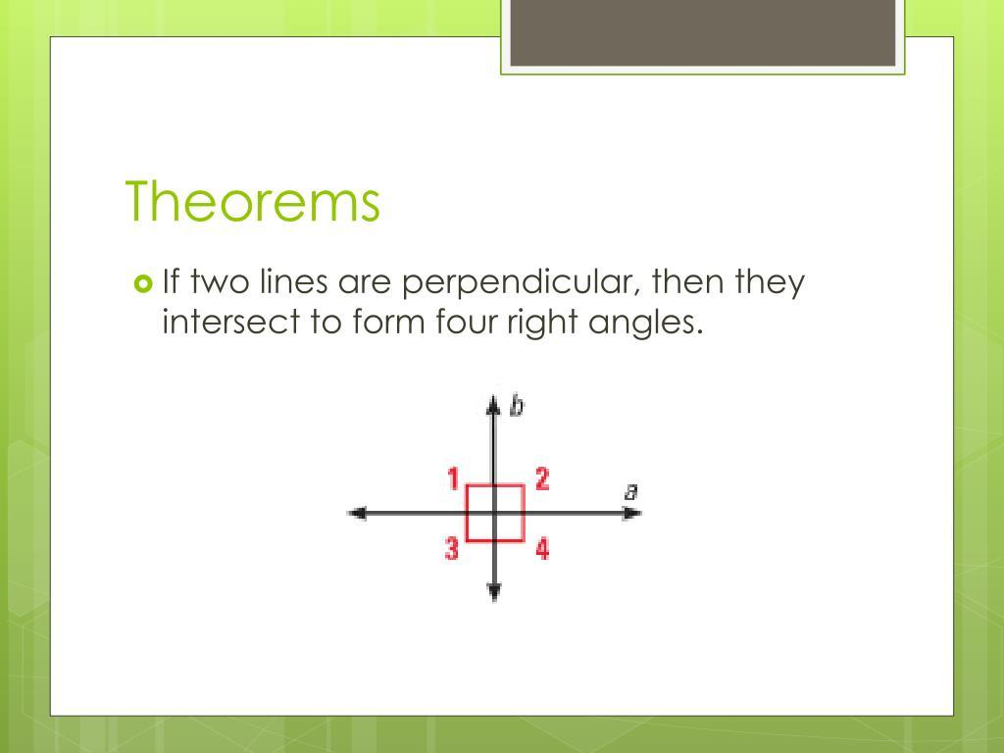

Perpendicularity and Complementary Angles
# Source: AI Source: Provided by: [Data Path: Persons Table -> ID Column: 1, Name_En Column: Motasem Essam] -> From: [ChatGPT] on [7/25/2026]
Two acute angles whose measures add to ${90}^{∘}$ are complementary.
For example:
$${30}^{∘}+{60}^{∘}={90}^{∘}$$
When perpendicular lines are divided by another ray, complementary angle relationships can occur.
$$\boxed{α+β={90}^{∘}}$$
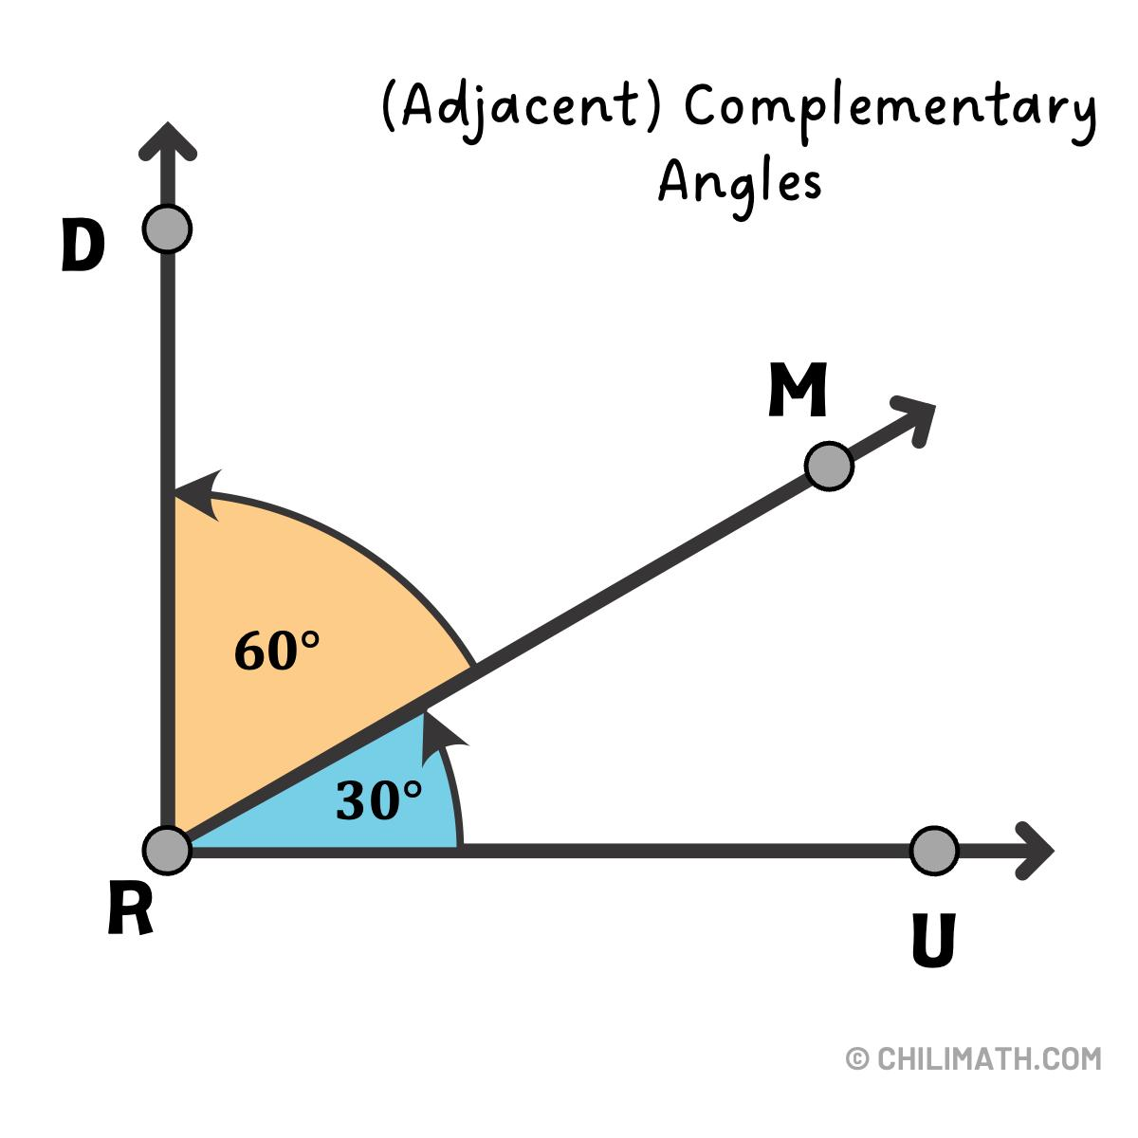
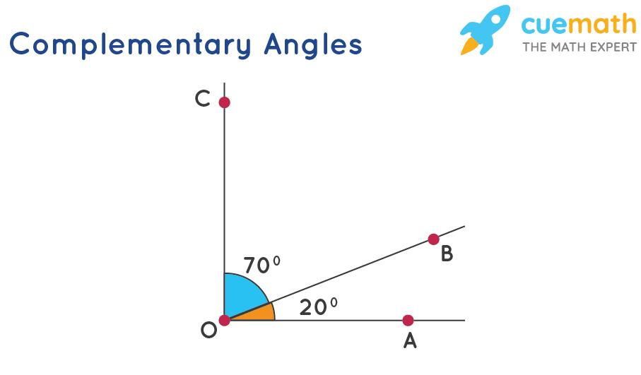
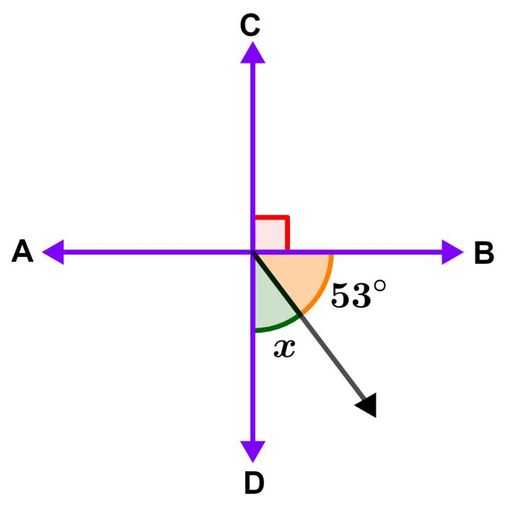
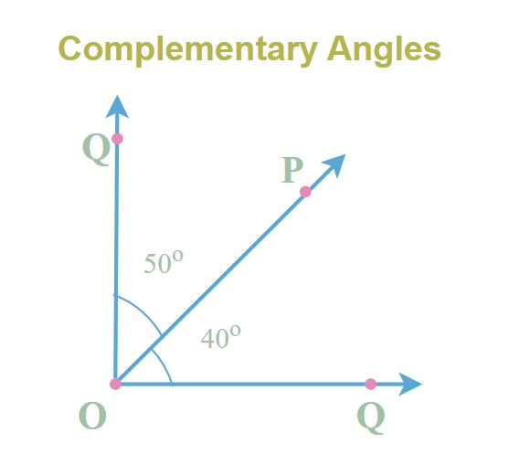
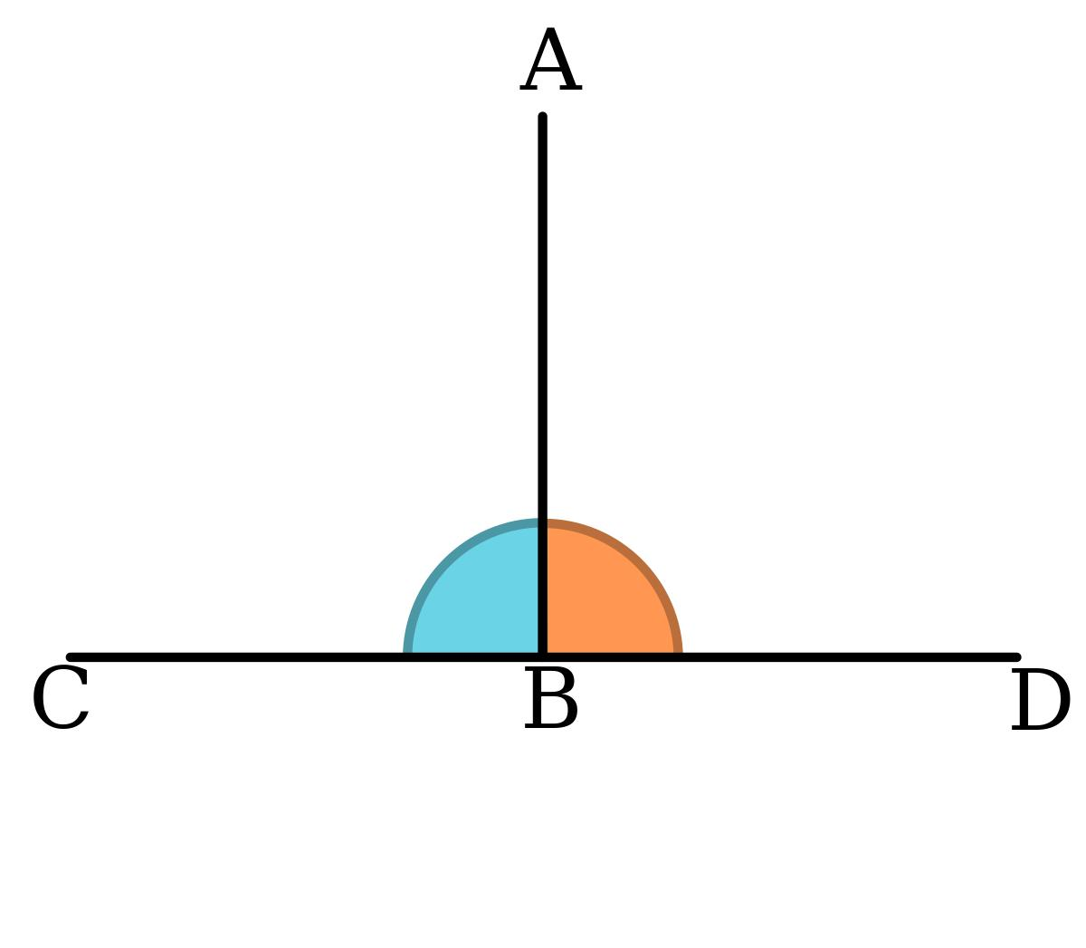

Perpendicular Lines and Transversals
# Source: AI Source: Provided by: [Data Path: Persons Table -> ID Column: 1, Name_En Column: Motasem Essam] -> From: [ChatGPT] on [7/25/2026]
A transversal that is perpendicular to one of two parallel lines is also perpendicular to the other.
If:
$$l_{1}∥l_{2}$$
and:
$$t⊥l_{1}$$
then:
$$\boxed{t⊥l_{2}}$$
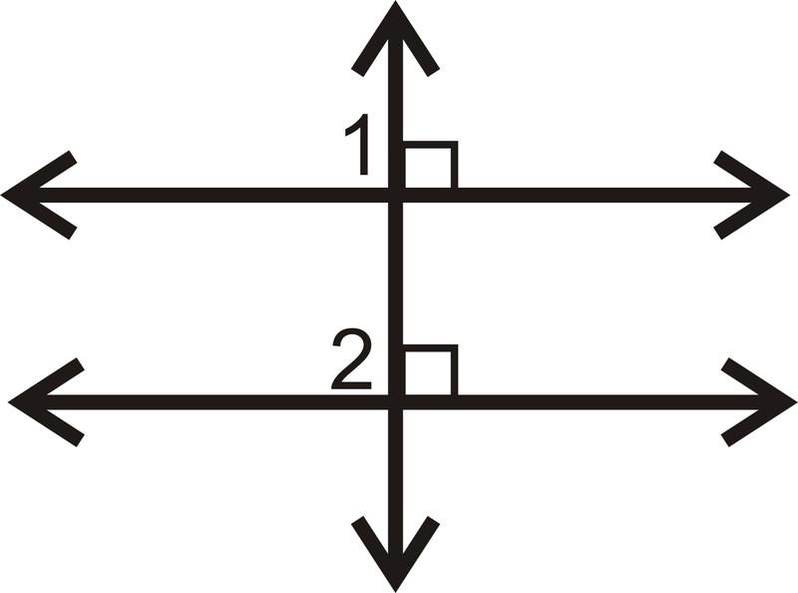
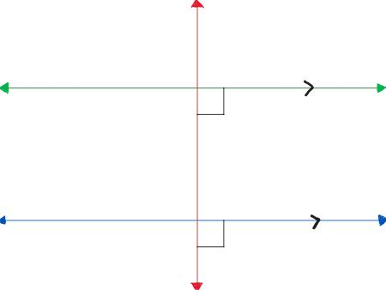
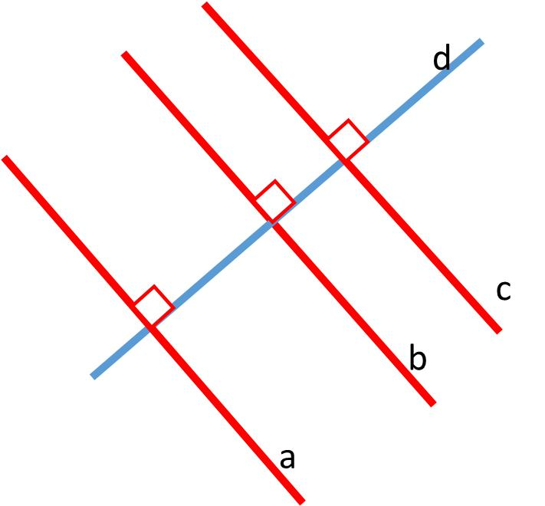
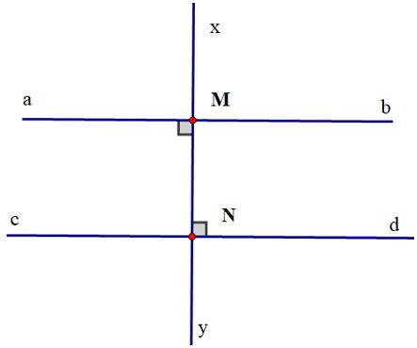
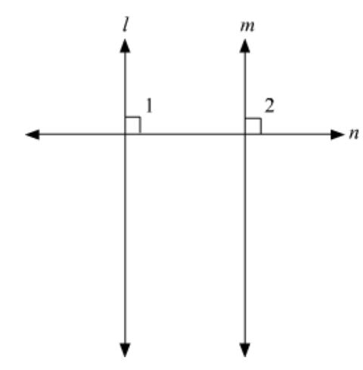
This is an important relationship between parallelism and perpendicularity.

Perpendicularity and Geometric Constructions
# Source: AI Source: Provided by: [Data Path: Persons Table -> ID Column: 1, Name_En Column: Motasem Essam] -> From: [ChatGPT] on [7/25/2026]
Perpendicular lines can be constructed using:
- Compass.
- Straightedge.
- Set square.
- Protractor.
- CAD tools.
A classical construction can create the perpendicular bisector of a line segment.
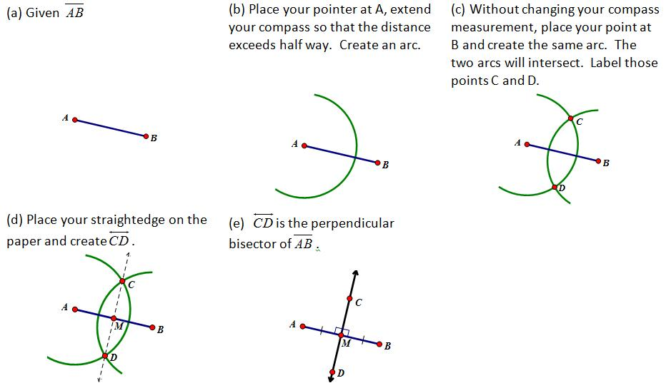
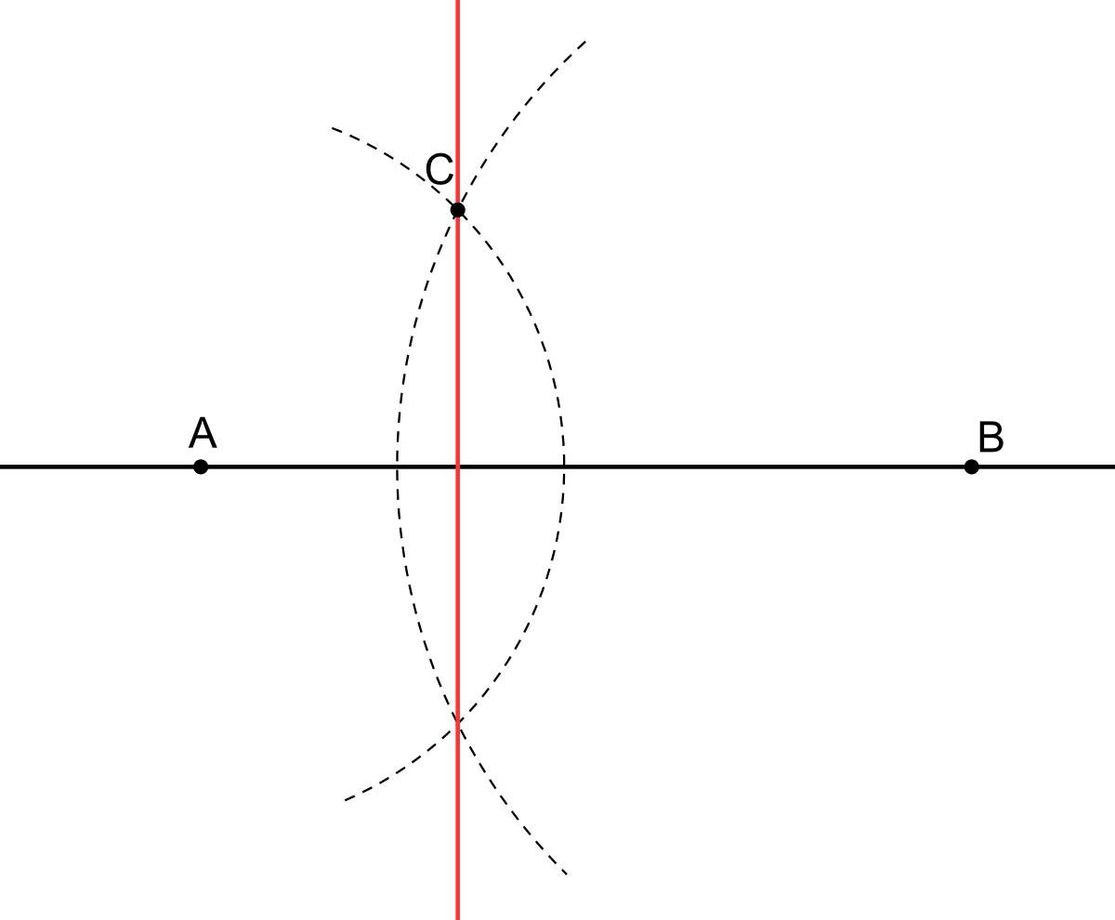
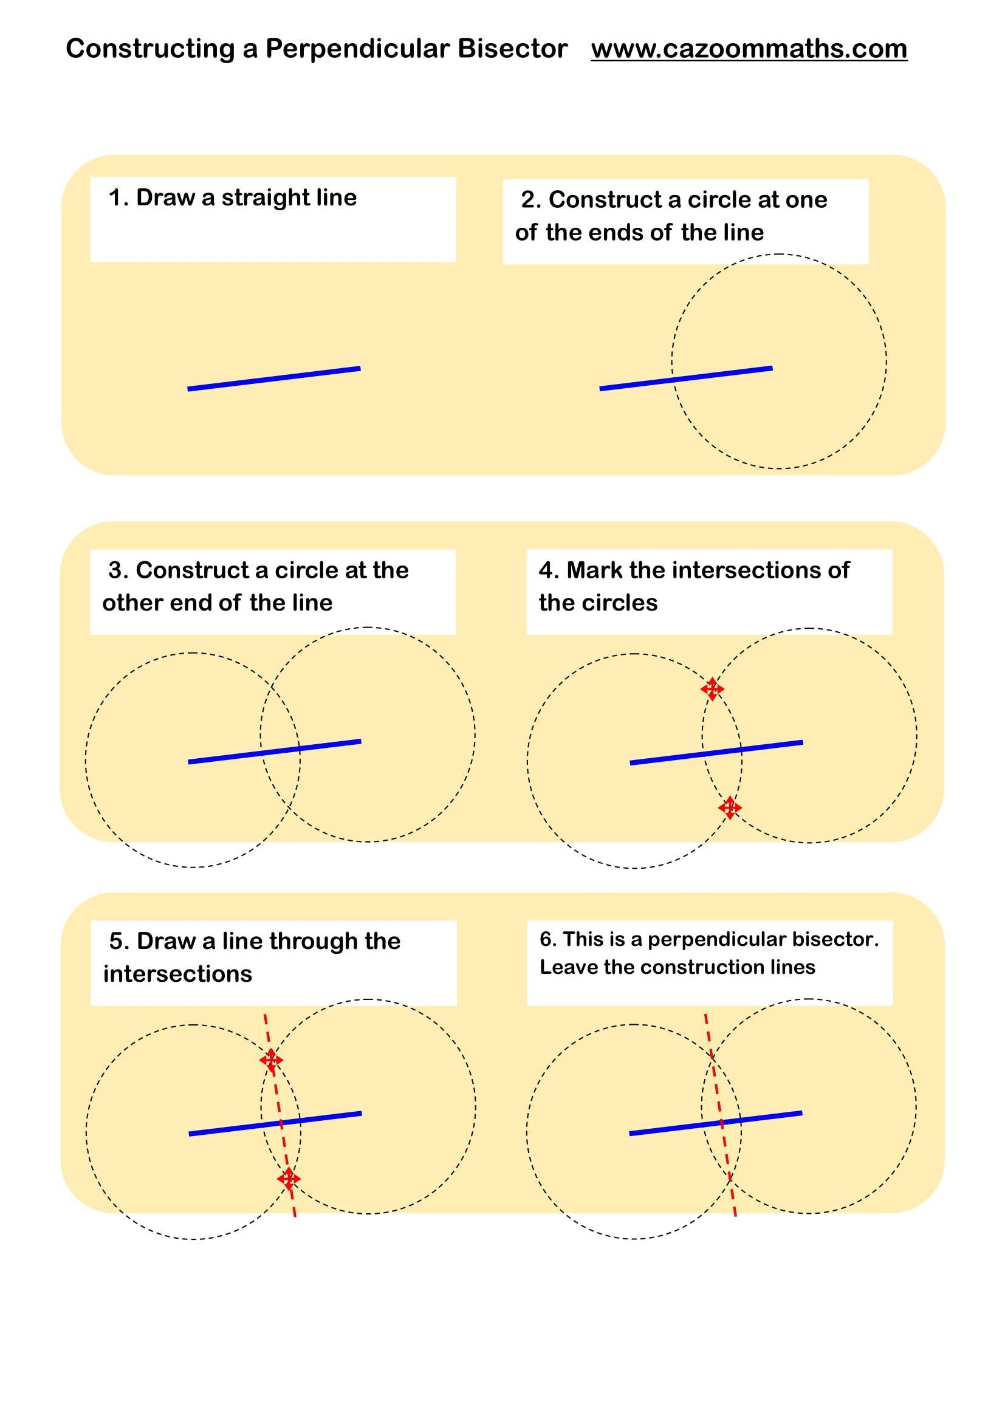
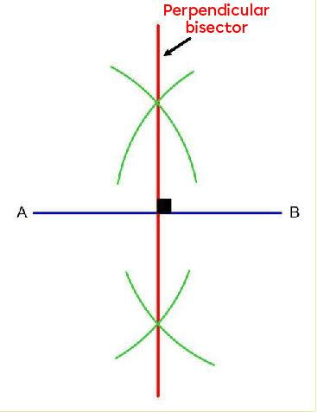
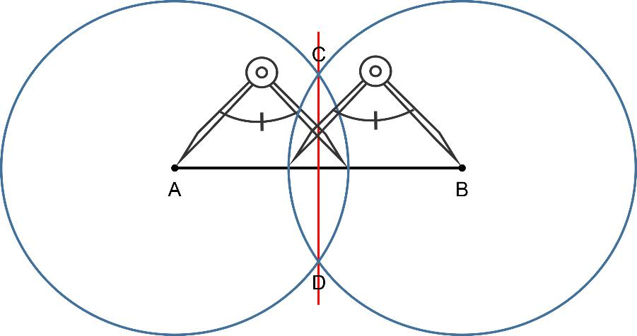

Perpendicularity in Architecture
# Source: AI Source: Provided by: [Data Path: Persons Table -> ID Column: 1, Name_En Column: Motasem Essam] -> From: [ChatGPT] on [7/25/2026]
Perpendicularity is essential in architecture.
Examples include:
- Walls meeting floors.
- Columns meeting foundations.
- Window frames.
- Door frames.
- Building corners.
- Structural components.
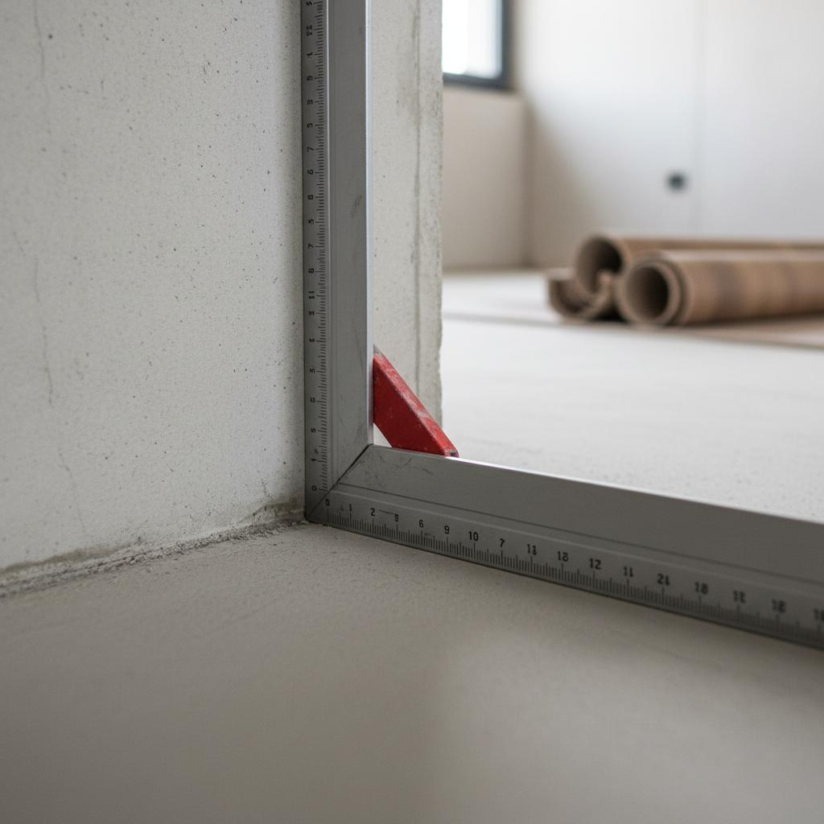

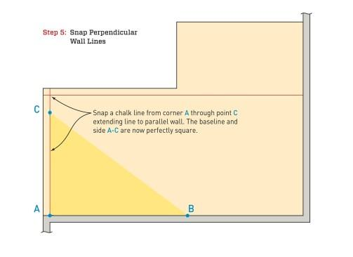


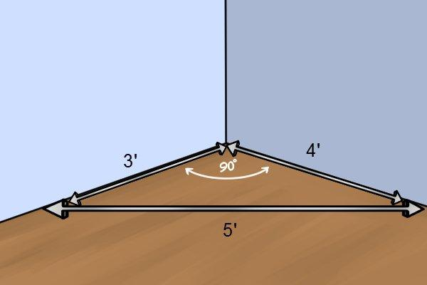

Perpendicularity in Engineering
# Source: AI Source: Provided by: [Data Path: Persons Table -> ID Column: 1, Name_En Column: Motasem Essam] -> From: [ChatGPT] on [7/25/2026]
Engineers use perpendicular relationships in:
- Mechanical components.
- Machine parts.
- Structural frames.
- Bridges.
- Manufacturing.
- Technical drawings.
- Mechanical joints.
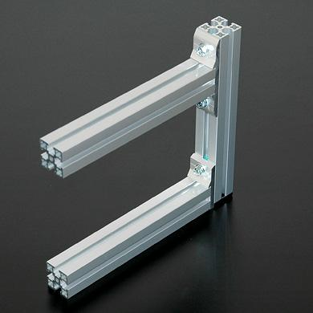
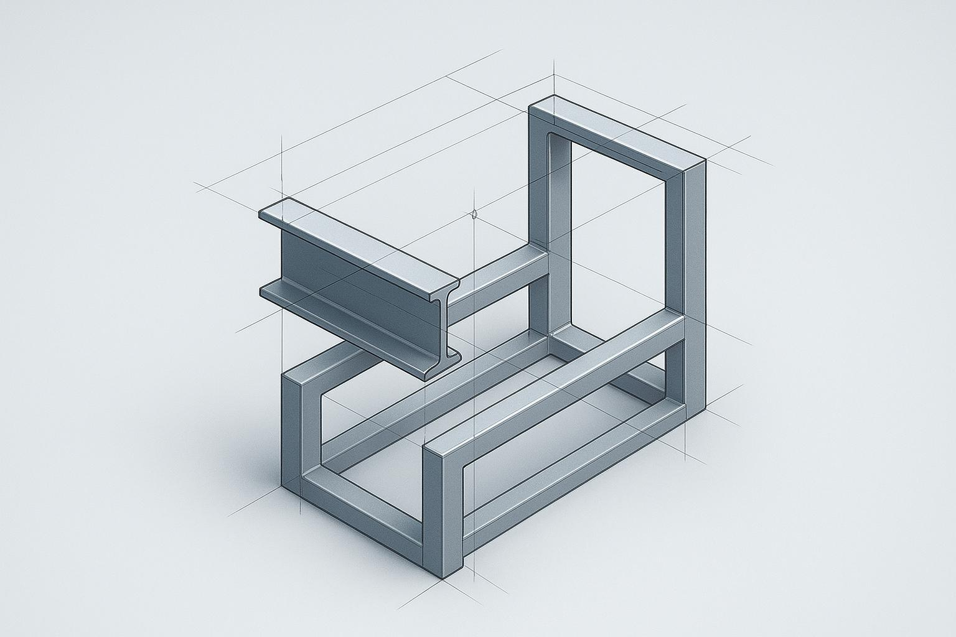
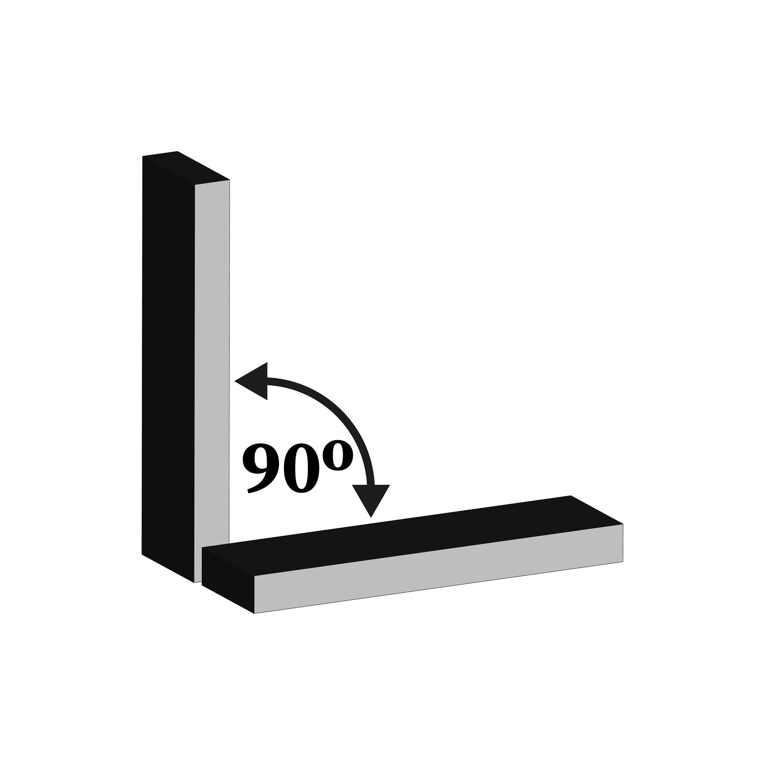
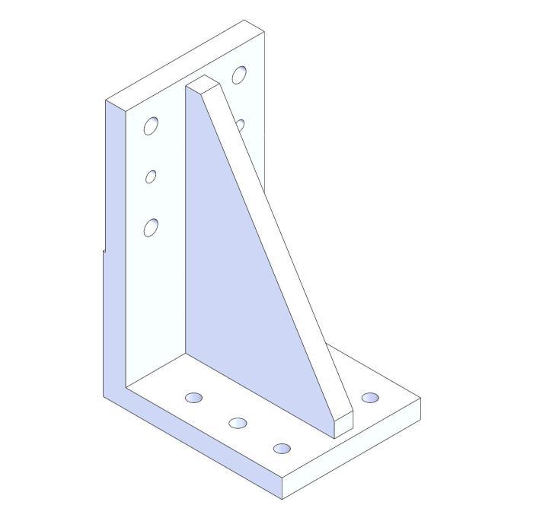
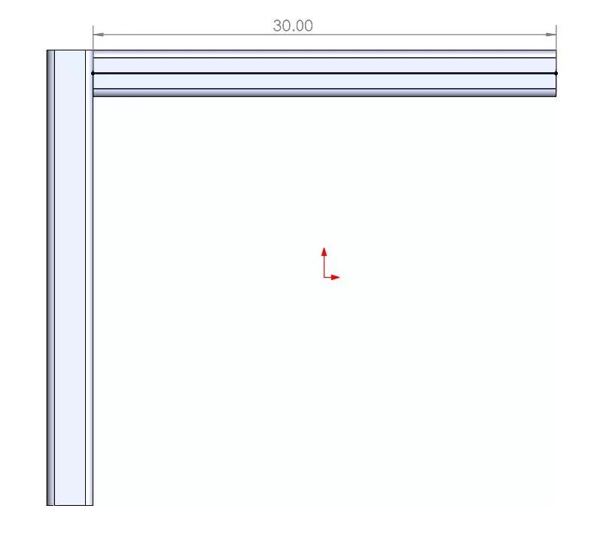

Perpendicularity in CAD
# Source: AI Source: Provided by: [Data Path: Persons Table -> ID Column: 1, Name_En Column: Motasem Essam] -> From: [ChatGPT] on [7/25/2026]
CAD systems commonly provide perpendicular constraints.
A designer can specify:
$$\boxed{AB⊥CD}$$
and the software maintains the ${90}^{∘}$ relationship while the drawing is modified.
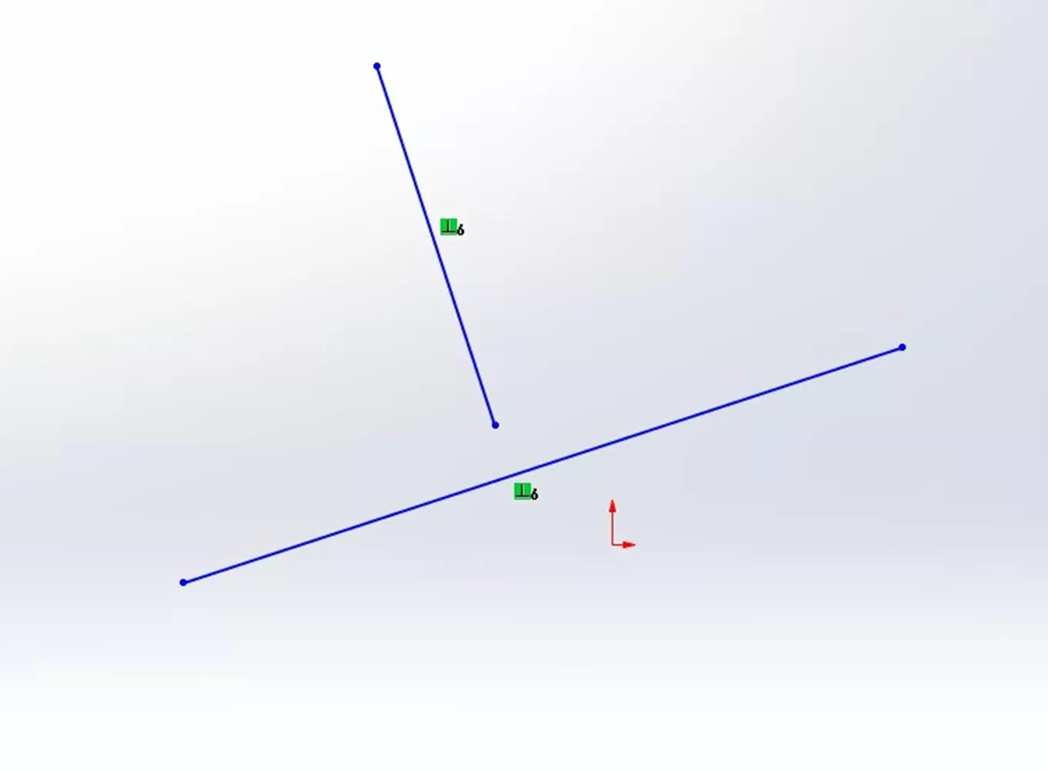
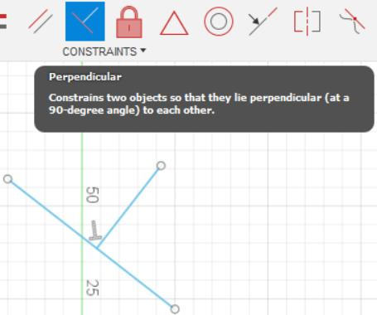
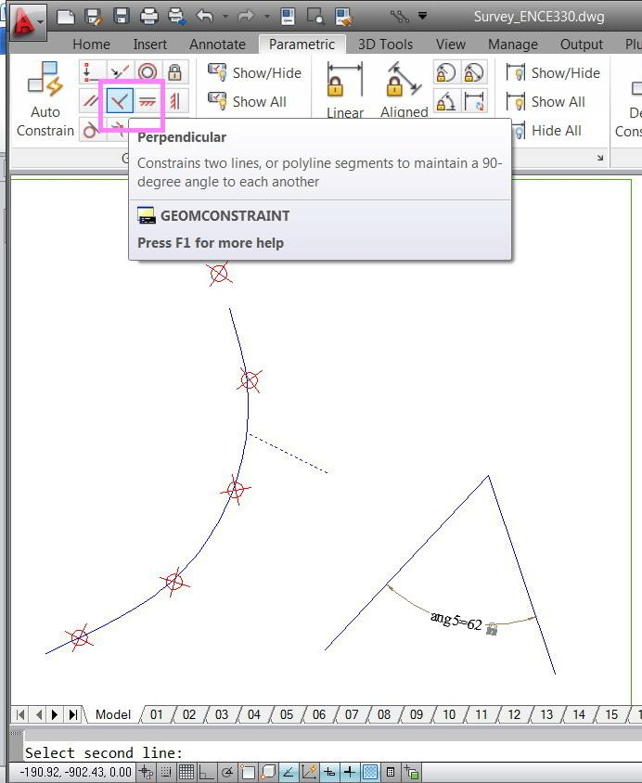
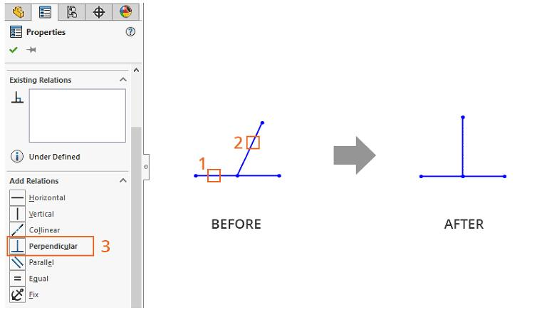
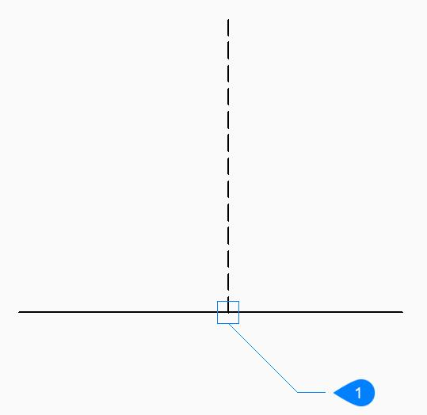

Perpendicularity in Real Life
# Source: AI Source: Provided by: [Data Path: Persons Table -> ID Column: 1, Name_En Column: Motasem Essam] -> From: [ChatGPT] on [7/25/2026]
Examples include:
- Wall and floor.
- Wall and ceiling.
- Corners of a book.
- Edges of a sheet of paper.
- Grid lines.
- Crossroads meeting at right angles.
- Window frames.
- Door frames.
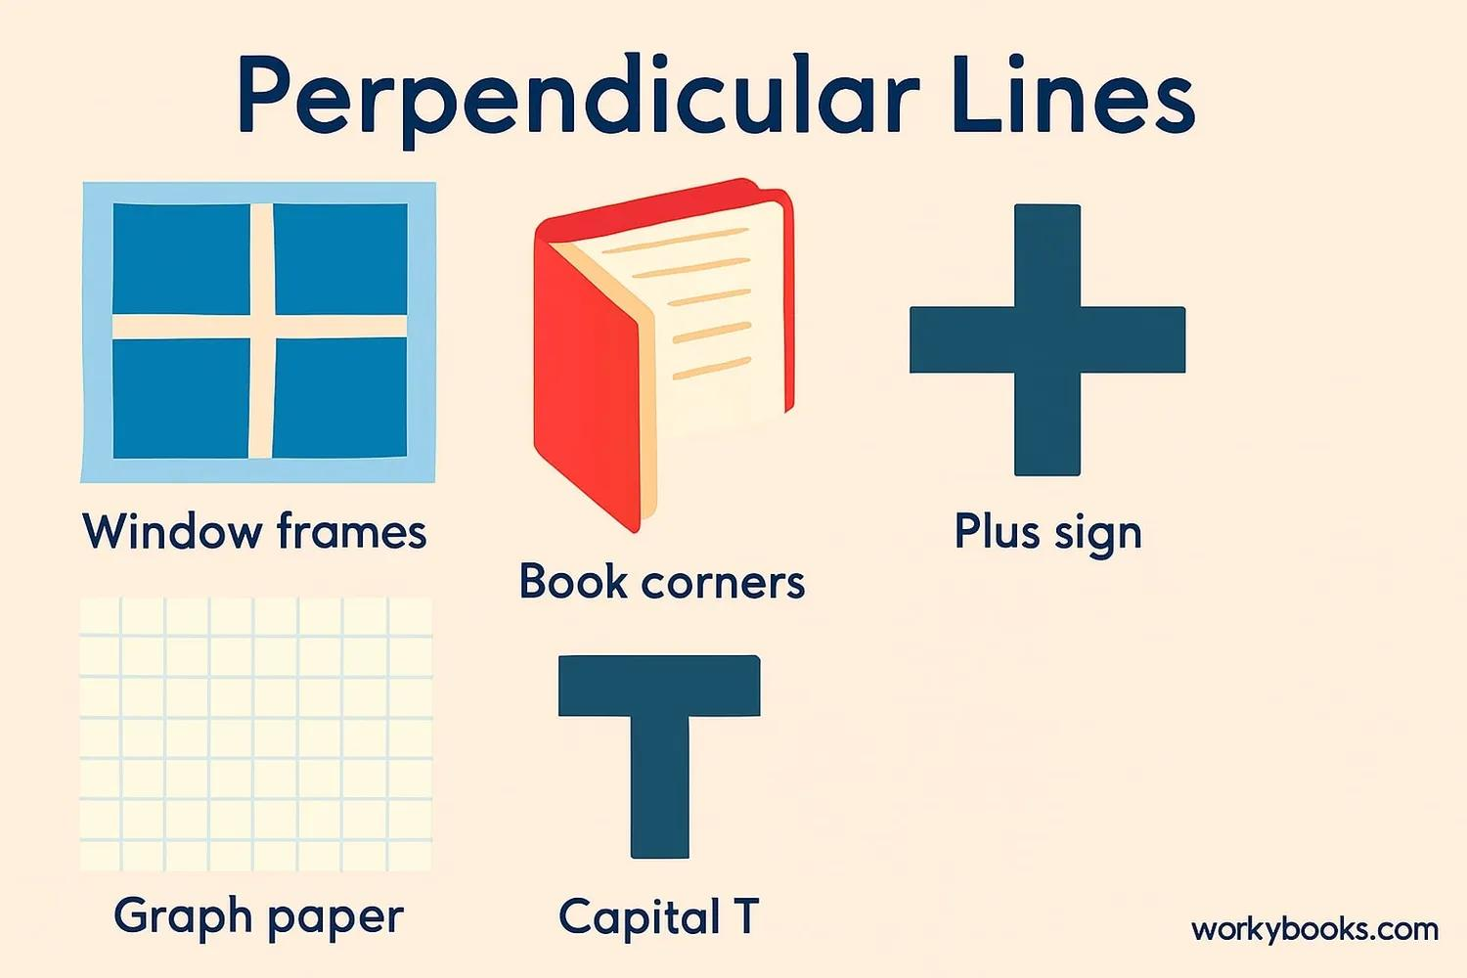
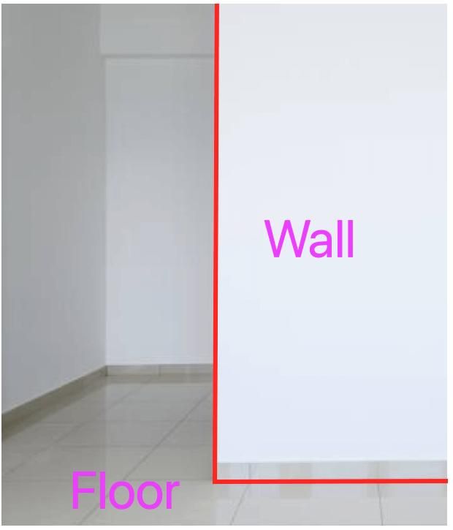
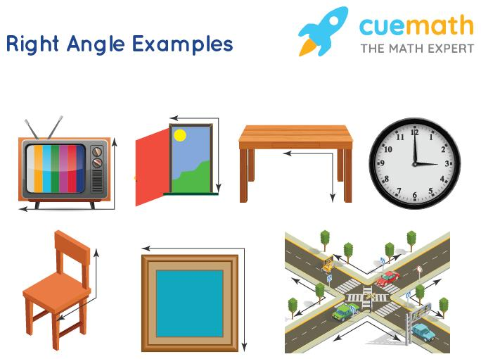
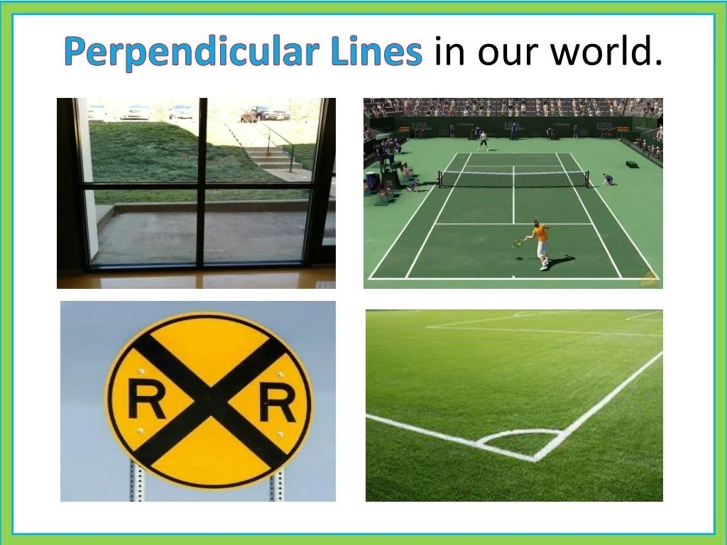

Applications
# Source: AI Source: Provided by: [Data Path: Persons Table -> ID Column: 1, Name_En Column: Motasem Essam] -> From: [ChatGPT] on [7/25/2026]
Perpendicularity is important in:
- Plane Geometry
- Euclidean Geometry
- Coordinate Geometry
- Trigonometry
- Construction Geometry
- Architecture
- Civil Engineering
- Mechanical Engineering
- Surveying
- CAD
- Manufacturing
- Computer Graphics

Advantages
# Source: AI Source: Provided by: [Data Path: Persons Table -> ID Column: 1, Name_En Column: Motasem Essam] -> From: [ChatGPT] on [7/25/2026]
Studying perpendicularity helps to:
- Identify right angles.
- Construct accurate geometric figures.
- Find shortest distances.
- Construct perpendicular bisectors.
- Analyze right triangles.
- Find triangle altitudes.
- Understand coordinate geometry.
- Solve geometric problems.
- Design accurate structures.
- Create precise CAD models.

Limitations
# Source: AI Source: Provided by: [Data Path: Persons Table -> ID Column: 1, Name_En Column: Motasem Essam] -> From: [ChatGPT] on [7/25/2026]
Perpendicularity:
- Requires an intersection in the usual plane-geometry sense.
- Specifically represents a ${90}^{∘}$ relationship.
- Does not mean that two objects have equal lengths.
- Does not imply that the objects are parallel.
- Can be difficult to identify accurately in distorted drawings.
- In three-dimensional geometry, perpendicularity between lines can require more careful treatment.

Comparison with Related Concepts
# Source: AI Source: Provided by: [Data Path: Persons Table -> ID Column: 1, Name_En Column: Motasem Essam] -> From: [ChatGPT] on [7/25/2026]
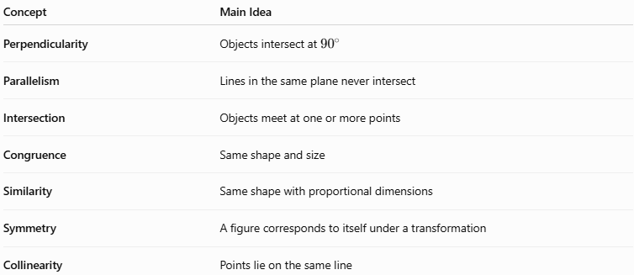
Concept | Main Idea
Perpendicularity | Objects intersect at ${90}^{∘}$
Parallelism | Lines in the same plane never intersect
Intersection | Objects meet at one or more points
Congruence | Same shape and size
Similarity | Same shape with proportional dimensions
Symmetry | A figure corresponds to itself under a transformation
Collinearity | Points lie on the same line

Parallelism vs. Perpendicularity
# Source: AI Source: Provided by: [Data Path: Persons Table -> ID Column: 1, Name_En Column: Motasem Essam] -> From: [ChatGPT] on [7/25/2026]
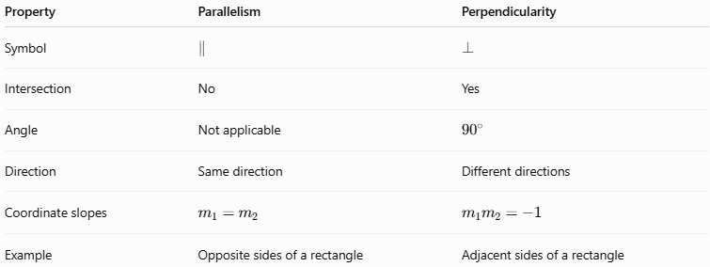
Property | Parallelism | Perpendicularity
Symbol | $$∥$$ | $$⊥$$
Intersection | No | Yes
Angle | Not applicable | $${90}^{∘}$$
Direction | Same direction | Different directions
Coordinate slopes | $$m_{1}=m_{2}$$ | $$m_{1}m_{2}=-1$$
Example | Opposite sides of a rectangle | Adjacent sides of a rectangle
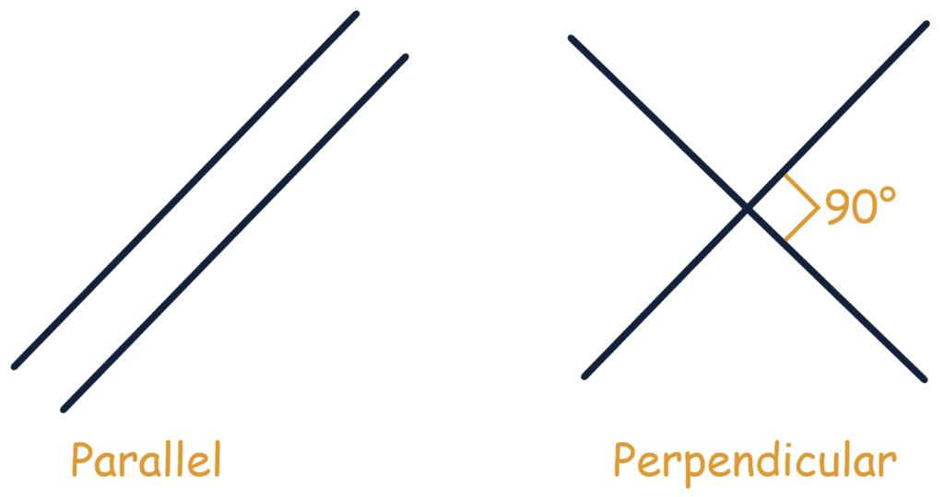
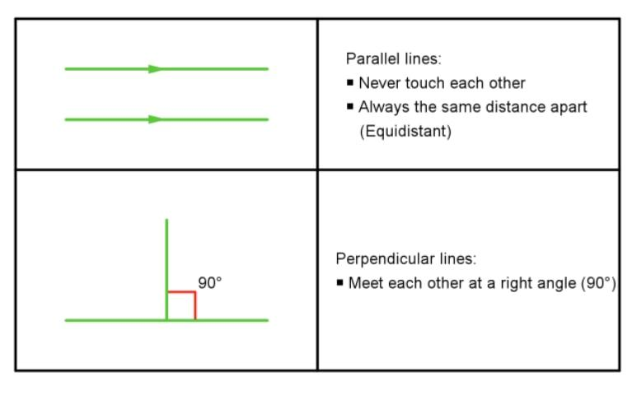

Key Points
# Source: AI Source: Provided by: [Data Path: Persons Table -> ID Column: 1, Name_En Column: Motasem Essam] -> From: [ChatGPT] on [7/25/2026]
- Perpendicularity is a geometric relationship in which two objects intersect at a right angle.
- The right angle measures:
$$\boxed{{90}^{∘}}$$
- The symbol is:
$$\boxed{⊥}$$
- Perpendicular lines form four right angles at their intersection.
- For non-vertical lines in coordinate geometry:
$$\boxed{m_{1}m_{2}=-1}$$
- A perpendicular bisector crosses a segment at its midpoint and at ${90}^{∘}$.
- An altitude of a triangle is perpendicular to the opposite side.
- The shortest distance from a point to a line is measured perpendicularly.
- Adjacent sides of rectangles and squares are perpendicular.
- Some geometric figures, such as rhombi and squares, have perpendicular diagonals.
- Perpendicularity is fundamental to geometry, construction, architecture, engineering, surveying, and CAD.

Conclusion
# Source: AI Source: Provided by: [Data Path: Persons Table -> ID Column: 1, Name_En Column: Motasem Essam] -> From: [ChatGPT] on [7/25/2026]
Perpendicularity is a fundamental type of Geometric Relationship describing two geometric objects that intersect at a right angle of ${90}^{∘}$. It is represented by the symbol $⊥$. Perpendicularity is essential for understanding right angles, right triangles, altitudes, perpendicular bisectors, distances, coordinate geometry, and geometric constructions. It also provides an important foundation for practical applications in architecture, engineering, construction, surveying, manufacturing, and CAD, where precise ${90}^{∘}$ relationships are frequently required.

